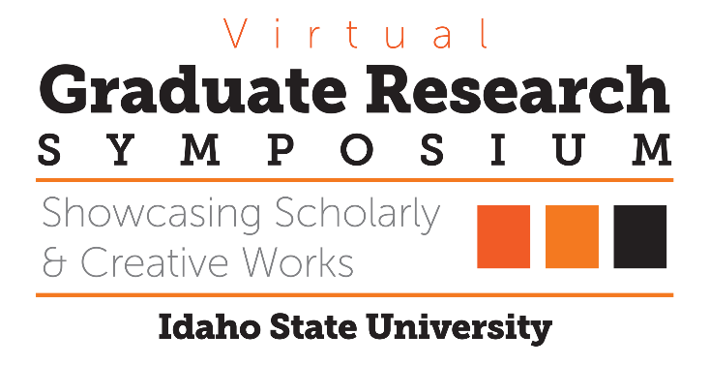

# Congratulations to the 2020 Graduate Research Symposium Award Recipients!

3MT Winner

Presented to

Looking Beyond Leaves: Nutrient Leaching Potential of Seasonal

Litterfall in the Urban Forest

*Sophie Hill*

# Top Oral Presentation in Biological, Physical & Natural Sciences

Presented to

Determining Residence Times and Sources of Groundwater and

Carbon in a Semi-Arid Basin

*Sara Warix*

# Top Oral Presentation in Education, Learning & Training

Presented to

Scenario-based E-learning and Feedback Type Effects on Learning

and Motivation

*Sacha Johnson*

# Top Oral Presentation in Health, Nutrition & Clinical Sciences

Presented to

Pilot Study of Functional Outcomes from a Modified Intensive

Comprehensive Aphasia Program

*Thomas Gonzalez*

# Top Oral Presentation in Health, Nutrition & Clinical Sciences

Presented to

Shame in Supervision: Interpretative Phenomenological Analysis in

Counselor Education

*William Lane*

# Top Oral Presentation in Humanities, Behavioral & Social Sciences

Presented to

Testing the State and Trait Accuracy Model III: The Effects of Affect

Congruence on the Accuracy of Trait and State Judgments

*Sheherezade Krzyzaniak*

# Top Poster Presentation in Biological, Physical & Natural Sciences

Presented to

Determining Residence Times and Sources of Groundwater and

Carbon in a Semi-Arid Basin

*Jennifer Souza*

# Top Poster Presentation in Engineering, Physical & Mathematical Sciences

Presented to

Disaster Management Robotics in collaboration with Idaho National

Laboratory (INL).

*Uma Shankar Medasetti*

# Top Poster Presentation in Health, Nutrition & Clinical Sciences

Presented to

Bone Targeting Delivery of Small Angiotensin Peptides: A Focus on

AT2 Receptor

*Arina Ranjit*

# Top Poster Presentation in Humanities, Behavioral & Social Sciences

Presented to

Maternal trauma, markers of HPA axis dysregulation, prenatal

depression, and breastfeeding

*Lillian Bengtson*