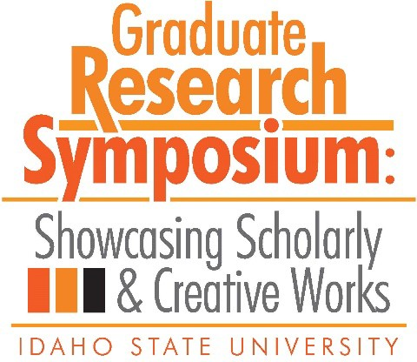

# Congratulations to the 2019 Graduate Research Symposium Award Recipients!

1st Place – 3MT

Presented to

The Impact of Prior Information on Personality Judgment Accuracy

*Jacob Gibson*

# 2nd Place – 3MT

Presented to

The Oriental Superheroes: A Discussion of the Political Questions

posed in G. Willow Wilson’s Cairo: A Graphic Novel and the Ms.

Marvel comic books.

*Noran Amin*

# 3rd Place – 3MT

Presented to

A Peel Inside the Eggshell: How a Baby Bird’s

Nervous System Develops to Control Breathing

*Jessica Whitaker- Fornek*

# People’s Choice – 3MT

Presented to

Understanding the Link Between Sleep and Suicidality:

A Preliminary Analysis of an Underlying Neuropsychological Mechanism

*Stephanie McManimen*

# Top Oral Presentation in Biological, Physical & Natural Sciences

Presented to

Groundwater Geochemistry and Flow in the Spring Mountains, NV:

Implications for the Death Valley Regional Flow System

*Sara Warix*

# Top Oral Presentation in Education, Learning & Training

Presented to

Real World Retention: A Qualitative Analysis of the Career Path

Internship

at Idaho State University

*Staci Phelan*

# Top Oral Presentation in Health, Nutrition & Clinical Sciences

Presented to

Quantification of Cellular Ceramide by Targeting Sphingomyelin Synthase In Cancer Cells Utilizing Anhydrophytosphinsoine, jaspine B.

*Farjan Afrin, James Lai, Srinath Pashikanti, Apurba Dutta*

# Top Oral Presentation in Humanities, Behavioral & Social Sciences

Presented to

Examining Political Behaviors “Power/Knowledge” through

Brave New World & Walden Two

*Christopher Brown*

# Top Poster Presentation in Biological, Physical & Natural Sciences

Presented to

Habitability Potential of Enceladus: An Analog Study of

Lo’ihi Seamount System in Hawaii

*Angela Garcia & Ashley Shields*

# Top Poster Presentation in Education, Learning & Training

Presented to

Professional Development in Rural Schools

*Laura Sheridan*

# Top Poster Presentation in Health, Nutrition & Clinical Sciences

Presented to

Quantification of Cellular Ceramide by Targeting Sphingomyelin

Synthase

In Cancer Cells Utilizing Anhydrophytosphinsoine, jaspine B. *Farjana Afrin, Jared Barrott, James Lai, Srinath Pashikanti, Apurba Dutta*

# Top Poster Presentation in Humanities, Behavioral & Social Sciences

Presented to

Are Two Methods Better Than One? Examining the Utility and

Comparability of

Metric and Morphoscopic Traits to Estimate Ancestry

*Hannah Dawson*

# Top Poster Presentation in People’s Choice

Presented to

Metal Isotope Movement in Human Dental Tissue

*Rebekah Rakowski, Samantha Blatt, Amy Michael, John Dudgeon, Kateea Peterson*