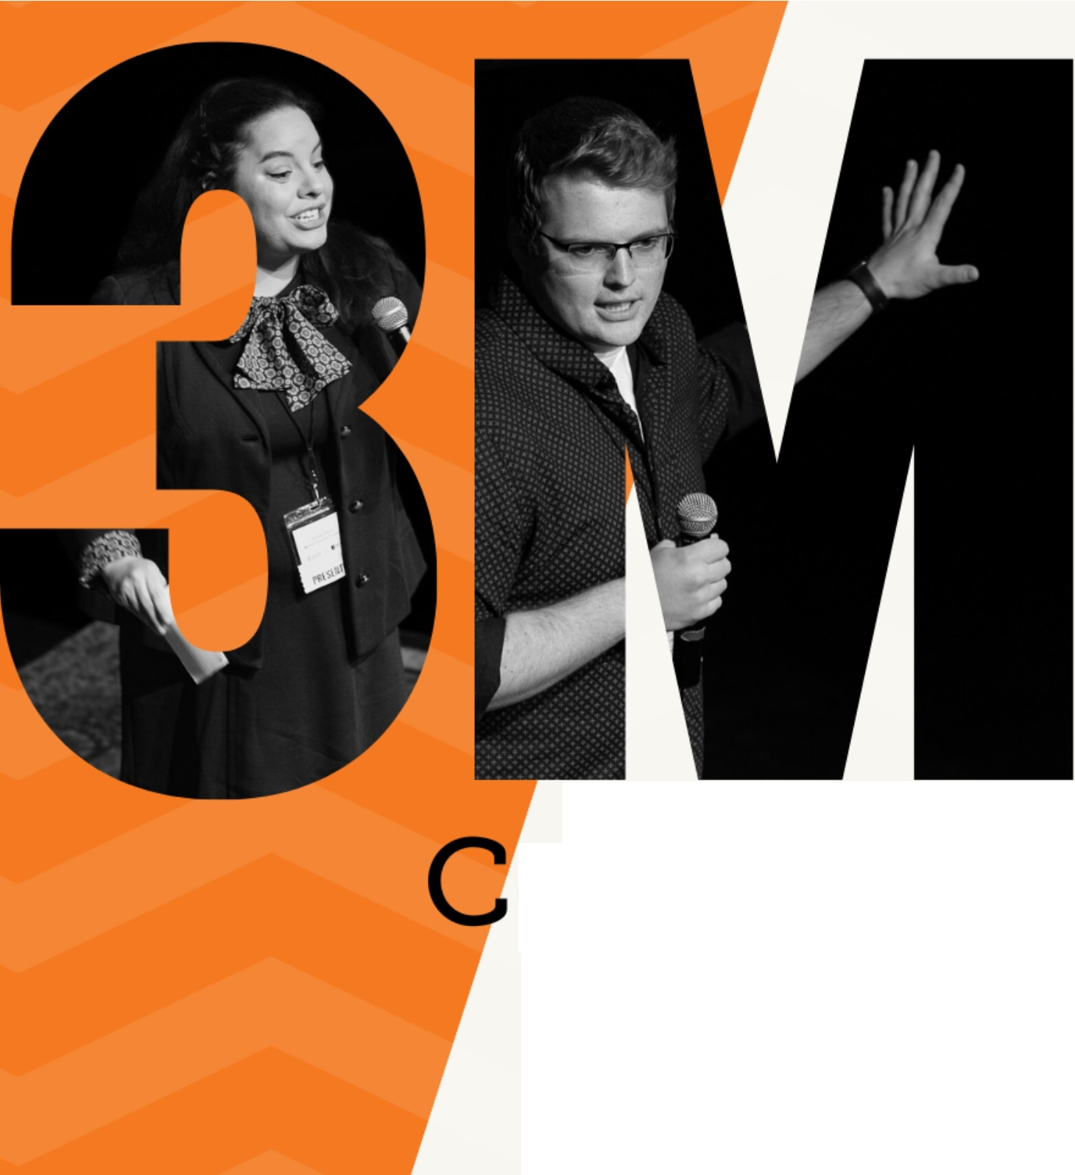**Idaho State University**

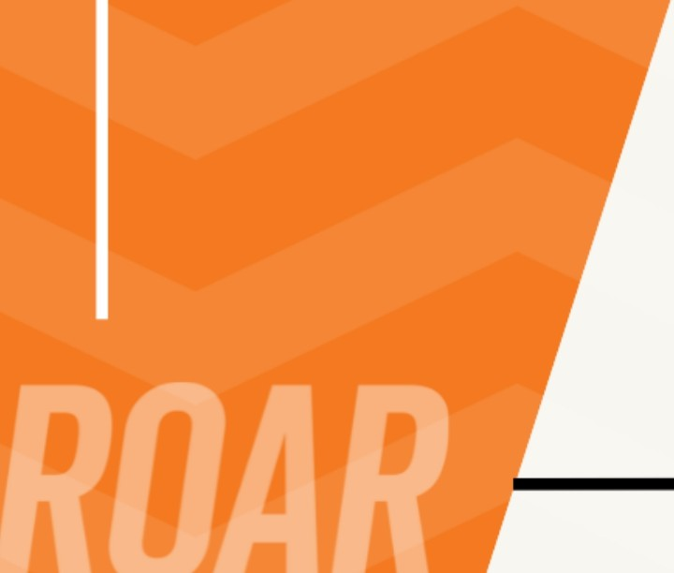

**Graduate School's**

**7th Annual**

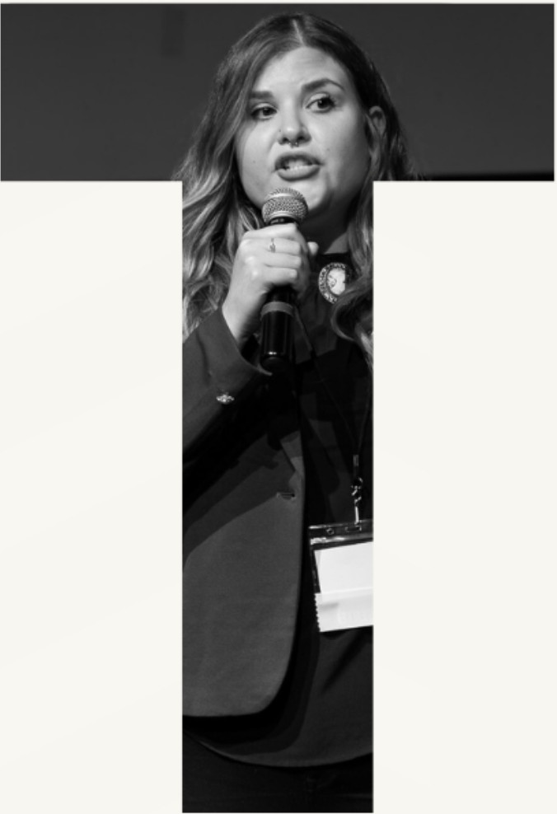

**Competition**

November 9, 2023

**LE and** Thelma E. Stephens Performing Arts Center

®THREE

MT

MINUTE

THESIS

# Idaho State University's Land Acknowledgment Statement

Acknowledging Native lands is an important way to honor and respect Indigenous peoples and their traditional territories. The land on which Idaho State University’s Pocatello campus sits is within the original Fort Hall Reservation boundaries and is the traditional and ancestral home of the Shoshone and Bannock peoples. We acknowledge the Fort Hall Shoshone and Bannock peoples, their elders past and present, their future generations, and all Indigenous peoples, including those upon whose land the University is located. We offer gratitude for the land itself and the original caretakers of it.

As a public research university, it is our ongoing commitment and responsibility to teach accurate histories of the regional Indigenous people and of our institutional relationship with them. It is our commitment to the

Shoshone-Bannock Tribes and to ISU’s citizens that we will collaborate on future educational discourse and activities in our communities.

**Fall 2023**

**Three Minute Thesis Event Program**

**Table of Contents**

Idaho State University's Land Acknowledgment Statement 2

Letter from the Interim Dean of the Graduate School 4

Dean’s Excellence Fund 5

3MT History 6

Rules 6

Judging Criteria 6

Meet the 2023 Judges 8

Martin “Marty” Blair, Ph.D 8

Donna Lybecker, Ph.D 8

Esther Ntuli, Ed.D 9

Krystal Chanda 9

Agenda 10

3MT Competition 10

Awards Reception 14

Fall 2022 3MT Winners 15

Upcoming Events 16

Abstracts 18

Graduate Certiﬁcates 27

# Letter from the Interim Dean of the Graduate School

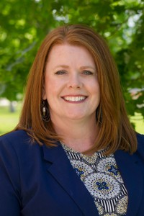

Welcome to the Graduate School's premiere research event - the Three-Minute Thesis Competition! Whether you are joining us as a graduate student participant, a judge, a faculty mentor, or an interested community member, we are thrilled to share your enthusiasm for the work you will see presented tonight.

In 2018, as a component of our Graduate Research Symposium, we held our inaugural 3MT event. After extensive recruitment, we started with 17 students and fewer than 30 audience members. Our goal to grow this event has been a wonder to witness. In addition to a full Black Box Theatre (with additional seating available), we received over 45 submissions for our 2023 3MT, and we also have a global live-streaming audience.

I would be remiss if I did not express my gratitude to the Graduate School team for their tireless efforts in organizing a fantastic event for our exceptional students.

Additionally, our students have reached this point thanks largely to the faculty members who devote so much of their time to working with graduate students. The trust, support, and mentorship are greatly appreciated by our graduate students.

As we have watched students prepare for tonight, we are in awe at the collective work contributions to our community, state, region, and the world. Should the students you hear this evening provoke thought, inspire you, or speak to you, would you consider supporting these students and others like them by contributing to the Dean's Excellence Fund? The fund goes directly to students who take the top awards for our 3MT and the spring Graduate Research Symposium.

Thank you for supporting the 3 Minute Thesis Competition and the Graduate School's efforts to showcase these exceptional students!

Signature of Dr. Tracy Collum

Dr. Tracy Collum

Interim Dean of the Graduate School

# Dean’s Excellence Fund

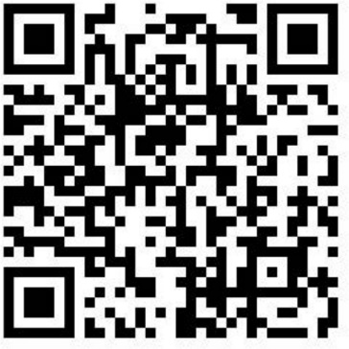

The mission of the Graduate School is to promote and support excellence in graduate education. To support this mission, the Graduate School is afﬁliated with the Idaho State University Family of Funds via the Dean's Excellence Fund.

You can honor students for their outstanding academic and creative work by making a donation to the Graduate School's Dean's Excellence Fund. Graduate students who place in our

3-Minute Thesis Competition and our Graduate Research Symposium are eligible for cash prizes, which are partially funded by the Dean's Excellence Fund.

Your support of the Dean's Excellence Fund at the Graduate School enables us to have an instantaneous, direct effect on our graduate students. Your contribution will maintain our vision to be a leading force in high-quality graduate education. Donation amounts are ﬂexible; however, to have the greatest positive impact on our GradBengals, consider setting up a recurring monthly gift.

To make a one-time or ongoing donation to the Graduate School's Dean's Excellence Fund, simply scan the QR code above. A card reader will also be offered as a gift option at the awards reception for your convenience.

We are grateful for your attendance, support, and generosity and look forward to seeing you at our Graduate Research Symposium on March 13, 2024.

# 3MT History

Three Minute Thesis (3MT®) is a research communication competition developed by The University of Queensland (UQ) in 2008, whereby graduate students have exactly three minutes to present a compelling oration on their thesis and its signiﬁcance. 3MT challenges students to consolidate their ideas and research discoveries to be presented concisely to a non-specialist audience.

Enthusiasm for the 3MT concept and its adoption in numerous universities led to the development of an international competition, of which the Graduate School has been participating in since 2018.

## Rules

* A single static PowerPoint slide is permitted (no slide transitions, animations, or 'movement' of any description; the slide is to be presented from the beginning of the oration).
* No additional electronic media (e.g. sound and video ﬁles) are permitted.
* No additional props (e.g. costumes, musical instruments, laboratory equipment) are permitted.
* Presentations are limited to 3 minutes maximum, and competitors exceeding 3 minutes are disqualiﬁed.
* Presentations are to be spoken word (e.g. no poems, raps, or songs).
* Presentations are to commence from the stage.
* Presentations are considered to have commenced when a presenter starts their presentation through movement or speech.
* The decision of the adjudicating panel is ﬁnal.

## Judging Criteria

Comprehension & Content

* Did the presentation provide an understanding of the background to the research question being addressed and its signiﬁcance?
* Did the presentation clearly describe the key results of the research, including conclusions and outcomes?
* Did the presentation follow a clear and logical sequence?
* Was the thesis topic, key results, and research signiﬁcance and outcomes communicated in language appropriate to a non-specialist audience?
* Did the speaker avoid scientiﬁc jargon, explain terminology, and provide adequate background information to illustrate points?
* Did the presenter spend adequate time on each element of their presentation

- or did they elaborate for too long on one aspect, or was the presentation rushed?

Engagement & Communication

* Did the oration make the audience want to know more?
* Was the presenter careful not to trivialize or generalize their research?
* Did the presenter convey enthusiasm for their research?
* Did the presenter capture and maintain their audience's attention?
* Did the speaker have sufﬁcient stage presence, eye contact, and vocal range; maintain a steady pace, and have a conﬁdent stance?
* Did the PowerPoint slide enhance the presentation - was it clear, legible, and concise?

# Meet the 2023 Judges

### Professional portrait of Dr. Martin "Marty" BlairMartin “Marty” Blair, Ph.D.

Vice President of Research & Economic Development

Dr. Martin “Marty” Blair is currently serving as the Vice President of Research & Economic Development at the Idaho State University Pocatello campus, having been appointed in April 2022. Prior to his arrival at ISU, Dr. Blair was Executive Director at the University of Montana’s Rural Institute for Inclusive Communities. He has a decades-long history of being a support to Universities, but an even longer history of supporting students; he started his career as a special education teacher and now stands as a distinguished Doctor of Education and Disability Policy. As a big advocate for inclusivity and education, Dr. Blair has acquired more than an impressive $90 million in public and private grants and contracts to better support community-based research, training, service, and public policy initiatives. A well-published author of more than 100 publications, Dr. Blair is a fantastic addition to our Judges’ Panel.

### Professional Portrait of Dr. Donna LybeckerDonna Lybecker, Ph.D.

Professor in Political Science

Idaho State University is honored to have Dr. Donna Lybecker as a Professor in our Political Science Department, having also previously served as the Chair of the Political Science Department and as Acting Vice President for Research. Dr. Lybecker specializes in environmental politics and international relations, making her a great choice for a judge of the 3MT Competition. Before joining the ISU faculty in 2007, Dr. Lybecker worked as a contractor with the U.S. Geological Survey and as a post-doc with the U.S. Forest Service. Dr. Lybecker has displayed an incredible talent for going above and beyond, as evidenced by her being awarded the Distinguished Teacher Award in 2013, the Outstanding Service Award in 2016 and 2017, and, more recently, the ISU Achievement Award for ISU’s 2023 Homecoming. Outside of the work she provides to ISU, Dr. Lybecker is also a member of the United States Environmental Protection Agency National Advisory Committee, the chair of the Selection Committee for the Bert & Phyllis Lamb Prize in Political Science, an Associate Editor for the Social Science Journal and for the Journal for Sustainable Society, and a published author whose publications include co-authoring two books.

### Professional portrait of Dr. Esther NtuliEsther Ntuli, Ed.D.

Associate Dean of the College of Education

Dr. Esther Ntuli became the Associate Dean of the College of Education in 2022, initially joining the ISU Department of Teaching in Educational Studies in 2011. Heavily grounded in leadership, Dr. Ntuli has chaired and served on various departmental, college, and university committees. One of her notable accomplishments was in 2020 when she co-organized the Inaugural College of Education Diversity, Equity, and Inclusion Conference to be a resource to educators, families, and students. A powerful contributor, Dr. Ntuli has served as an editorial board member and a peer reviewer for several research journals, as a senior committee review member for the International Academic Forum, as a board member of the ISTE Afﬁliate Wyoming Technology-Engagement-Curriculum Connection Conference, and as an external reviewer for doctoral dissertations at the University of Pretoria and the University of South Africa. Having received the College of Education 2020 Faculty Excellence Award and been named a ﬁnalist for the 2021 East Idaho Women of Inﬂuence in the education category, we are grateful to have Dr. Ntuli contribute her skills and experience to the 3MT Competition.

### Picture of Krystal Chanda in professional attire with a background of river stones.Krystal Chanda

Principal Engineer at A&E Engineering, Inc.

Krystal Chanda is a venerable alumnus of ISU. Ms. Chanda attended ISU beginning in 2002 and ﬁnished up in 2012, receiving a Master of Science in Civil Engineering with a focus in Hydrology. She went on to utilize her extensive knowledge base to be the lead civil design engineer for the incredible Portneuf Wellness Complex and now works as a professional engineer with A&E Engineering, Inc. Ms. Chanda plays an active role in her community, serving as the President of the Idaho Academy of Science and Engineering - Eastern Council, a member of the Idaho Society of Professional Engineers, the Practitioner Advisor for the Idaho State University American Society of Civil Engineers Student Chapter, the Stage and Entertainment Coordinator for the Kind Community, and the Coordinator for the Southeast Idaho MATHCOUNTS Chapter. In 2015, Ms. Chanda was recognized as a nominee for the Professional of the Year Award and was recently honored as one of the 2018 Idaho Business Review Women of the Year. In the write-up recognizing her in the Idaho Business Review, Ms. Chanda says, “If you have passion or desire, you’ll ﬁnd the potential and the power to do it. Passion comes ﬁrst, and the other two will follow.” With women still being a minority in the ﬁeld of engineering, Ms. Chanda continues to encourage all people to pursue their passions without reservation.

# Agenda

**November 9, 2023**

L.E. & Thelma E. Stephens Performing Arts Center in Pocatello, Idaho

## 

## 3MT Competition

Black Box Theatre

**Join Us Virtually via YouTube Live**

#### QR Code for YouTube Livestream of the competition Competition

#### <https://youtube.com/live/XJW2Ebpz4yM?feature=share>

#### QR Code to watch YouTube Livestream of the Awards Reception Awards Reception

<https://youtube.com/live/0mC6alqC3cQ?feature=share>

**6:00 PM Event Introduction & Opening**

Dr. Tracy Collum, Interim Dean

###### Welcome

Dr. Karen Appleby, Vice Provost for Faculty Success and Instruction

###### Three Minute Thesis Presentations

Presenter 1 **Whitney Boyce**

Physical Therapy - DPT

Presenter 2 **Ahmed Ashour**

Engineering & Applied Science - PhD

Presenter 3 **Bethany Hickey**

Nutrition - MS

Presenter 4 **Anyauba Nmaju**

Pharmaceutical Science - PhD

Presenter 5 **Joshua Luker**

Business Administration - MBA

Presenter 6 **Kyler Sayer**

Chemistry - MS

Presenter 7 **Alaa Alamri**

Nutrition - MS

Presenter 8 **Austin Young**

Biology - MS

Presenter 9 **Jarrett Mitton**

Public Health - MPH

Presenter 10 **Spencer Roop**

Biology - PhD

Presenter 11 **Jessica Sargent**

Political Science - DA

Presenter 12 **Arifa Islam Champa**

Computer Science - MS

Presenter 13 **Yomna Mohamed**

Engineering & Applied Science - PhD

Presenter 14 **Antora Dev**

Electrical & Computer Engineering - MS

Presenter 15 **MD Masud Un Nabi**

Communication - MA

Presenter 16 **James D. Wardell**

Political Science - DA

Presenter 17 **Jordan Oman**

Pharmaceutical Science - PhD

Presenter 18 **Verlyn Glenn**

Nursing Practice - DNP

Presenter 19 **Sudip Bhattarai**

Applied Physics - PhD

Presenter 20 **Adam Zambie**

Biology - MS

Presenter 21 **Rifat Ara Tasnim**

Engineering & Applied Science - PhD

Presenter 22 **Sarah Menish-Geryk**

Political Science - DA

Presenter 23 **Alexis Packer**

Public Health - MPH

Presenter 24 **Darin Letzring**

Homeland Security & Emergency Management - MS

Presenter 25 **Ailun Li**

Clinical Psychology - PhD

Presenter 26 **Sajal Acharya**

Microbiology - MS

Presenter 27 **Pik Ching Wong**

Clinical Rehabilitation Counseling - MCoun

Presenter 28 **Dawn Amos**

Public Health - MPH

Presenter 29 **Maria Reinoso**

Geology - MS

Presenter 30 **Peggy Lelesi**

Dental Hygiene - MS

Presenter 31 **Seyedeh Melika Akaberi**

Pharmaceutical Science - PhD

Presenter 32 **Kierra Burns**

English - MA

Presenter 33 **ShaRhonda Stevenson**

Counselor Education & Counseling - PhD

Presenter 34 **Aysha Zahidie**

Public Health - MPH

Presenter 35 **Juliette Bedard**

Anthropology - MS

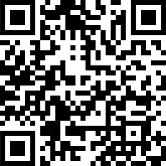

**Vote for People’s Choice Award**

Scan QR code with your photo app and make your selection.

## Awards Reception

Rotunda

###### Opening

Dr. Tracy Collum

Interim Dean of the Graduate School

###### Winners Announced

Anna Siddoway

Interim Director of the Graduate School

###### Reception

*Enjoy libations & hors d'oeuvres*

**ISU Student Musicians**

School of Performing Arts | Department of Music

Bohan Hou

*Violin*

Bachelor of Music in Performance

Ian Woodruff

*Cello*

Bachelor of Arts in Music

# Fall 2022 3MT Winners

###### Fall 2022 1st Place Winner Lauren French

###### 1st Place

##### Lauren French

Physical Therapy - DPT

Utilization of Gamiﬁcation to Enhance Online Learning Outcomes Within Doctor of Physical Therapy Curriculum

###### Fall 2022 2nd Place Winner Ritesh Yadav

###### 2nd Place

##### Ritesh Yadav

Business Administration - MBA

Foreign Aid and Gender Inequality: Sectoral Impact of Aid

###### Fall 2022 3rd Place Winner Jacob Harris

###### 3rd Place

##### Jacob Harris

Sociology - MA

The QAnon Infection: How Families Have Reacted to Members' Conspiratorial Identities

###### Fall 2022 People's Choice Winner Jeffrey Okojie

###### People’s Choice Award

##### Jeffrey Okojie

Pharmaceutical Science - PhD

A Theranostic Approach for Synovial Sarcoma

# Upcoming Events

**Late Nights with the Graduate School**

##### Friday, December 1, 2023 | 7:00 p.m. - 9:00 p.m. ICCU Bengal Alumni Center, Pocatello, Idaho



**State Three-Minute Thesis Competition** Spring, 2024



**2024 Graduate Research Symposium** Wednesday, March 13, 2024 Earl R. Pond Student Union, Pocatello, Idaho

# Abstracts

(abstracts listed in order of presentation)

### Whitney Boyce

Physical Therapy - DPT

Does the Peabody Reﬂect All Bodies Worldwide

The Peabody Motor Assessment is used with children ages zero to ﬁve to quantify their motor skills in comparison to peers their age. While this may be resourceful when the child is of a similar country, socioeconomic standing, and culture as the peer group, the accuracy decreases when a population varies. Additional assessments need to be implemented and created to accurately assess populations with different cultural tendencies and values, such as those located deep in the Amazon of Ecuador.

Ahmed Ashour

Engineering & Applied Science - PhD

***A Spectrum Injection-Based Approach for Malware Prevention in RFID Systems*** RFID technology uses electromagnetic waves for data transfer but is vulnerable to malware attacks. To address this, an approach for RFID systems in the UHF band is proposed, optimizing spectrum usage, and introducing a spectrum injection-based approach (SIBA) with bandpass ﬁltering to enhance data reconstruction and counter malware. A noise reduction technique is also suggested for improved accuracy. These methods aim to improve eﬃciency and security in RFID systems.

Bethany Hickey

Nutrition - MS

Food Processing and Appetite Regulation: How Ultra-Processed Foods May Be Inﬂuencing What and How Much We Eat

The consumption of ultra-processed foods is increasing despite known associations between their intake and chronic diseases. Ultra-processed foods have undergone extensive manufacturing and have complex ingredient lists. A review of the literature was performed to investigate whether eating ultra-processed food compared to minimally processed food impacts appetite regulation and energy intake. The ﬁndings suggest an association between the degree of food processing and the body’s ability to regulate appetite and maintain energy balance.

Anyauba Nmaju

Pharmaceutical Science - PhD

Immunotherapeutic “Silver bullets” targeted at Necrotizing Infections

Necrotizing soft tissue infections (NSTIs) are deadly bacterial infections for which tissue debridement, including amputation, is the only life-saving treatment. Streptococcus pyogenes is the major pathogen implicated in this infection. Antibiotic treatment has been ineffective in managing these infections because they do not neutralize the toxins produced by this organism. We aim to develop antibody therapeutics that neutralize these toxins and provide better clinical outcomes for patients with this debilitating infection.

Joshua Luker

Business Administration - MBA

***Good Friends in Adverse Places: Finding Close Conﬁdants in Bad Workplaces*** There is a long anecdotal and literary tradition suggesting that close friendships often emerge among individuals who share particularly adverse experiences. Some workplaces are so diﬃcult that they create adverse experiences for their employees. Are employees in adverse workplaces more likely to form relationships with their coworkers? Data from the General Social Survey and qualitative interviews suggest that employees in bad workplaces are more likely to seek out a coworker for social support than those in better workplaces.

Kyler Sayer

Chemistry - MS

***The Analysis and Preparation of Polymeric Adhesives Using Garlic Essential Oil*** Modern adhesives are often petroleum-based making them ecologically damaging and unsustainable but are at the same time critical due to widespread use. In this study, we evaluate commercially available garlic essential oils as feedstocks for synthesis. Material properties including the adhesion strength, the thermal stability proﬁle, and the solubility of the adhesive were obtained using a variety of tests demonstrating the successful creation of a greener alternative to petroleum-based adhesives.

Alaa Alamri

Nutrition - MS

The Impact of Ramadan Fasting on Muslims' Eating Behaviors

Muslims worldwide observe Ramadan in the ninth Islamic month, fasting from sunset to sundown for a month. Prior research has explored the Ramadan Fasting (RF) effect on different measures. My study contributes ﬁndings on its association with disordered eating behaviors (DEB) using a validated tool assessing its signs. Results showed no signiﬁcant impact, but almost half the participants showed concerning DEB signs that increased during RF. Findings suggest a possible risk of DEB from RF; more studies will help guard against RF-induced DEB.

Austin Young

Biology - MS

How Have Migrant Birds Responded to 17 Years of Change

Billions of birds migrate annually on a global scale and they are highly vulnerable to environmental change. Behavioral and morphological features of some species appear to be undergoing change in response to environmental change. I am measuring physical and behavioral changes in birds migrating through Idaho and comparing my results to historical records. I am using my observations to understand the stresses being experienced by migrants and to help guide conservation actions to preserve these species.

Jarrett Mitton

Public Health - MPH

Adductor-Related Groin Injury: Prevalence and Etiology During Game-Related NCAA Football

An issue commonly debated in American football is the safety of using artiﬁcial turf during competition. The media coverage of this topic typically emphasizes anecdotal evidence from players and coaches rather than peer-reviewed literature. Prior epidemiological studies have shown that heavyweight artiﬁcial turf is just as safe, or safer, than natural grass. The purpose of this research will be to explore how differences in ﬁeld surface affect the incidence and etiology of adductor-related groin injuries in Division I college football.

Spencer Roop

Biology - PhD

Quantifying genetic variation in physiological and morphological measurements of mature big sagebrush (Artemisia tridentata) in a common garden setting.

Big sagebrush (Artemisia tridentata) is a widespread shrub in western North America. It has three subspecies, found along elevational and soil moisture gradients, that have been found to differ in palatability, chemical composition, genome size, etc. To explore differences in ecophysiology among A. tridentata, I measured traits relating to drought tolerance in A. tridentata in a common garden setting to better understand how genetic and environmental variables contribute to phenotypes in a widespread, drought-adapted shrub species.

Jessica Sargent

Political Science - DA

Teaching in Turbulent Times: A Pedagogical Survival Guide

College instructors face unique dilemmas due to students’ increased access to information via the internet/social media, increased political polarization, & the unprecedented events of the last few years. This research examines how using an optimistic pedagogical approach can positively inﬂuence students’ outlook on the world & their place in it by using pre & post-testing to gauge pedagogical success. Seven pedagogical approaches are discussed to aid instructors in their efforts to teach problems, focus on solutions, & encourage students.

Arifa Islam Champa

Computer Science - MS

The Perfect Lure: Scrutinizing Achilles' Heel of Machine Learning in Phishing Email Detection

This study explores the Achilles heel of machine learning (ML) in detecting phishing emails that manage to escape detection. Through examining misclassiﬁed emails, we discover elusive patterns leading to incorrect detection. Our analyses of curated datasets with various email features identify weaknesses of prominent ML models against sophisticated phishing attacks. The ﬁndings of both quantitative and qualitative analyses advance understanding of how to fortify ML algorithms against modern phishing schemes.

Yomna Mohamed

Engineering & Applied Science - PhD

Proteomic Data and AI for Early Alzheimer's Detection

Alzheimer’s disease causes irreversible brain damage before symptoms appear. Current diagnostic methods have limitations - expensive tests or subjective assessments. Emerging research analyzes proteomic biomarkers in blood plasma using machine learning to detect the earliest Alzheimer’s stages. Simple blood tests with AI analysis could revolutionize early detection, enabling timely interventions to slow progression.

Antora Dev

Electrical & Computer Engineering - MS

EEG-based Epileptic Seizure Detection using Morlet Wavelet Scalograms and Machine Learning Models

Epilepsy, marked by frequent seizures, affects millions globally. Pre-existing diagnostic strategies are challenging due to subjectivity and lengthy analysis. Our study leverages deep learning to transform EEG signals into CCMWT (provides time-frequency visualizations of non-stationary EEG data) scalograms with ﬁve models, including hybrid CNN-RNN designs. Impressively, our approach achieved a 99.62% test accuracy, surpassing previous models that reached 76.43% using simple CWT techniques.

MD Masud Un Nabi

Communication - MA

***Navigating the Online and Oﬄine Challenges of Journalism in the Digital Age*** This study examined the challenges faced by journalists in Idaho, Utah, Wyoming, and Montana, focusing on workplace stressors such as newsroom structure, social media harassment, and online and oﬄine diﬃculties. Findings showed that journalists who are professionally active on

social media receive mostly negative comments and are likely to receive abusive comments and threats. This made them afraid to cover stories in person, and many considered quitting the profession because of hateful, abusive comments and threats.

James D. Wardell

Political Science - DA

Drawing the Line: Perceptions of Generative Artiﬁcial Intelligence Use in Work and Academics

In the face of an unprecedented age of technological advancement, the ethical use of General Artiﬁcial Intelligence (GenAI) in academic and professional tasks demands scrutiny. This study, conducted in late 2023, delves into perceived ethical boundaries between comparable academic and workplace tasks. Through demographic and personality analysis, we seek to help shape the urgently needed discourse on GenAI’s integration into our academic institutions and workplaces.

Jordan Oman

Pharmaceutical Science - PhD

Discovery of Allosteric Modulator for the Treatment of Noise-Induced Hearing Loss

Hearing greatly impacts quality of life. The number of people affected by hearing loss has grown to be greater than 1.5 billion people. Despite our technological advances and medical understanding, hearing loss is generally permanent. Our research focuses on synthesis of novel pharmaceuticals targeting receptors within the inner ear that are involved in noise-induced feedback mechanisms.

Verlyn Glenn

Nursing Practice - DNP

Barriers To Nurse Practitioner Post-Graduate Fellowships

Current research indicates that post-graduate fellowships help transition new nurse practitioners into practice. However, few graduates choose to complete such training. My research explores the barriers nurse practitioners face in pursuing available fellowships.

Sudip Bhattarai

Applied Physics - PhD

Searching for new physics with electron interactions

The universe is a complex puzzle, and we try to solve it piece by piece using experiments like MOLLER. In this experiment, we are colliding two electrons to precisely measure a property of the tiny particles that can help explain how they make up everything in the universe. We are developing a unique detector system for this experiment that acts as an eye to see the particle interaction. My presentation summarizes how this detector contributes to the search for new physics and our understanding of the tiniest building block of our universe.

Adam Zambie

Biology - MS

How Much Stream is Enough? Does Amount of Remnant Habitat Predict a Decline in Genetic Diversity for Redband Trout Populations

A major concern for the conservation of species affected by habitat loss is lowered genetic diversity. Populations of redband trout historically had large amounts of suitable habitat in the waterways of the Snake River; however, due to habitat loss, they are now often limited to small headwater streams. To determine how much remaining stream habitat is suﬃcient to support genetically viable populations of redband trout I have conducted a ﬁeld study comparing the genetic diversity present in populations to the amount of habitat available.

Rifat Ara Tasnim

Engineering & Applied Science - PhD

Impact of Serious Games to Enhance the Eﬃcacy of Psychotherapeutic Techniques

As a consequence of rapid changes in social aspects, there is an escalation in the number of patients with mental illness. Although abundant effective psychotherapy strategies exist, many people avoid them due to misconceptions and stigma. Serious games can be a feasible solution to provide mental healthcare to a signiﬁcant percentage of people. A serious game is a video game developed to achieve an additional goal along with entertainment. Our research outcome demonstrated serious games' effectiveness in adopting psychotherapeutic techniques.

Sarah Menish-Geryk

Political Science - DA

The Personalities of Conspiracy Theorists: An Examination of the Inﬂuence of the Big Five Personality Traits on the Belief in Conspiracy Theories

This research will examine if certain personality traits are more likely to predict belief in conspiracy theories. Using a large national public opinion survey, this project examines the impact of the Big Five personality traits (openness, conscientiousness, neuroticism, agreeableness, and extroversion) on an individual’s belief in conspiracy theories. Analyses reveal that conspiracy theorists have unique personality traits that differentiate them from non-conspiracy theorists.

Alexis Packer

Public Health - MPH

The Effects of Spirituality and Religiosity on Body Image

Body image is a high concern among in the public health ﬁeld. Media has increased body comparison among individuals. Scholars are looking for way to ensure a positive body image not simply to avoid a negative body image. Our study uses snowball sampling to identify if higher levels of spirituality and more consistent religious practice is a protective factor to body image concern. Speciﬁcally, if better spiritualty instills a positive body image among college students who are members of the Church of Jesus Christ of Latter-Day Saints.

Darin Letzring

Homeland Security & Emergency Management - MS

Idaho Dam Safety Emergency Preparedness Project - Riding Herd on a Crash of Gray Rhinos

Southeastern Idaho has 20 high-hazard dams that pose a high probability high impact event. These are our local gray rhinos, according to author Michelle Wucker. The project reviewed activities of dam owners and found opportunities to improve emergency preparedness that could save lives if one or more of this crash of Gray Rhinos ever charged. The recommendations can help save lives and property while laying the groundwork for mitigation projects to tame the rhinos.

Ailun Li

Clinical Psychology - PhD

Psychotherapy Help-seeking Intentions and Preferences among K-12 Teachers in Taiwan

The purpose of this study was to understand Taiwanese K-12 teachers’ preference and intention towards mental health service. Data was collected from 128 K-12 Taiwanese teachers. Results indicated that K-12 teachers held the strongest preference for individual therapy. A signiﬁcant difference in intentions to seek treatment based on the referral source was also found. The results of this study have implications for encouraging treatment-seeking in Taiwanese K-12 teachers when they experience a mental health need.

Sajal Acharya

Microbiology - MS

Expression of the small RNA spd_sr78 in Streptococcus pneumoniae and identifying the cellular pathways it interacts with.

Streptococcus pneumoniae lives in the upper respiratory tract and can spread to other body parts. Evidence suggests small non-coding RNAs (sRNAs) are pivotal in regulating the transition from colonization to active infection, inﬂuencing virulence-related genes. This study focuses on sRNA spd_sr78 in the mgtA transcript, and we'll test its role in modulating intracellular metal levels. This involves optimizing sRNA extraction and monitoring spd_sr78 expression in varied growth conditions, providing crucial insights for future research.

Pik Ching Wong

Clinical Rehabilitation Counseling - MCoun

Using an Artiﬁcial Intelligence Application Prototype for Multiple Sclerosis and Mental Health Symptoms Management: Increasing Optimal Care and Community Integration

Multiple sclerosis (MS) is a chronic disease that interferes with the communication between the central nervous system and body. Huang, a sophomore at ISU diagnosed with PPMS, seeks support from a Clinical Rehabilitation Counselor. My thesis proposes a holistic HIPAA-compliant healthcare biobehavioral AI app prototype, Magpie, based on the “thriving vs succumbing” principle in clinical rehabilitation counseling, aiming to increase Huang’s optimal care outcomes while reducing MS-induced limitations toward full community integration.

Dawn Amos

Public Health - MPH

Predictors of Unintended Pregnancy and STI Co-Occurrence

Unintended pregnancy and sexually transmitted infections (STIs) are common in the United States. When unintended pregnancy and STIs co-occur, it can result in worse health outcomes for both women and infants. It is currently unclear how different risk factors, such as multiple sexual partners, predict the co-occurrence of unintended pregnancy and STIs. My research aims to address this gap in knowledge in hopes of contributing to more effective unintended pregnancy and STI interventions.

Maria Reinoso

Geology - MS

***Detrital zircon characterization of the Ganges and Brahmaputra drainage networks: Implications for Plio-Pleistocene sediment sourcing to the Bengal Fan.*** The Ganges-Brahmaputra river system and the Bengal Fan represent Earth’s largest source to sink system. Studying these systems and changes in sediment routing, help us to understand analogous systems and how tectonic and climatic forces inﬂuence Earth processes. Previous work showed a change in the sediment delivery in the system at the Plio-Pleistocene transition. We analyzed modern sediment sources with geochronology to characterize the U-Pb signature and determine the tectonic and climatic drivers of the changes in sedimentation.

Peggy Lelesi

Dental Hygiene - MS

A Protocol for Treating Post-COVID Condition Patients in Dental Settings

This study tested a Post-COVID Conditions assessment and treatment protocol in dental settings, utilizing a qualitative exploratory research design. 56 dental hygienists in California used the protocol for 6 weeks, and 20 were interviewed, revealing four themes: awareness, accessibility, resources, and complications. Subthemes included ease of use and guidance, while complications encompassed time, clinician hesitation, and patient lack of cooperation. The results increased awareness of symptoms and emerged as a valuable resource for clinicians.

Seyedeh Melika Akaberi

Pharmaceutical Science - PhD

Unlocking Viral Secrets: How viruses alter brain function

This thesis explores how viruses interfere with communication in the brain, and their contribution to neurodegenerative diseases. The aims are: 1) Identify viral components capable of altering neuronal function, 2) Determine how viruses produce this effect. We show that Rabies, Herpes, and Covid-19 inhibit the function of nicotine receptors in the brain, revealing new insights into the relationships between viruses and brain disorders such as Alzheimer's. This work opens exciting new avenues for innovative intervention, and treatment.

Kierra Burns

English - MA

Splitting the Self: The Use of Twins to Communicate Effects of Trauma

Trauma has a way of dividing us, both from those around us, and from our own sense of self. Critical trauma theory examines the way that trauma can fracture memory and identity, even challenging the limits of our language to express the effects of our experience. When language falters, how can an author adequately convey trauma that splits our identity, our sense of time, and even our social systems? My research examines how authors have used twins, especially in postcolonial contexts, to convey the effects of trauma on identity.

ShaRhonda Stevenson

Counselor Education & Counseling - PhD

Application of Universal Design to Multiculturalism within Counseling Graduate Education: A Clinical Rehabilitation Counselor Educator Approach

My thesis will focus on training strategies for Masters students in CACREP-accredited programs. The goal is to provide culturally competent and sensitive counseling services to individuals diagnosed with HIV/AIDS. This will be done by addressing the role of stigma in client service-seeking and treatment adherence behaviors using a rural context. Using universal design within education can create strategies to address access barriers to care and stigma across regions within the US.

Aysha Zahidie

Public Health - MPH

Attitudes toward People Living with HIV/AIDS and Willingness to Provide Care among Health Sciences Students at a Public University in the Mountain West Region

This is a cross-sectional study to assess attitudes toward people living with HIV/AIDS and their willingness to provide care among health sciences students. The study population includes undergraduate (ﬁrst through the ﬁnal year) and graduate students of health sciences and allied disciplines at Idaho State University in the Mountain West Region. This research project will help in identifying gaps in the existing curriculum based on which useful recommendations will be developed for consideration by curriculum review committees.

Juliette Bedard

Anthropology - MS

Indigenizing and Decolonizing Harm Reduction: an Application to the Missing and Murdered Indigenous Peoples crisis

The Missing and Murdered Indigenous Peoples crisis, rooted in structural vulnerability, requires culturally informed solutions. An Indigenized harm reduction approach employs a decolonized lens that promotes community-based leadership and peer support to lessen the impact of structural violence stemming from medico-legal investigations. When applied holistically and multisectorially, communities can create an equitable and inclusive environment that sustains long-term health and healing.

**Featured Graduate Certiﬁcates**

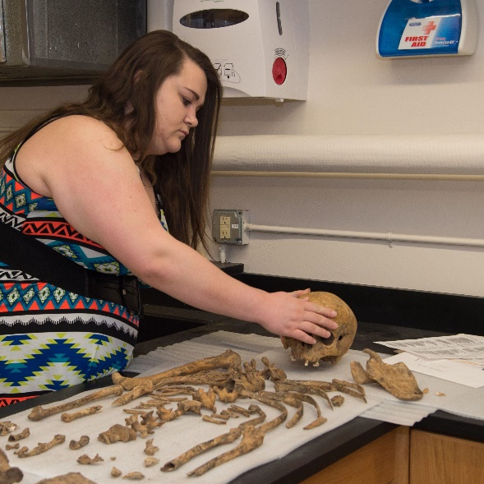

We currently offer **15 additional certiﬁcates** for graduate students to add to their degrees, or to separately enroll in.

From Assisted Animal Therapy to Biomedical Ethics, we strive to give our students the opportunity to further their career goals with the more precise knowledge and skills that interest them.

1. **Medical Anthropology**
2. **Public Health**
3. **Rural Health**
4. **Secure Cyber Operations**
5. **Animal Assisted Therapy**
6. **TESOL**
7. **Geotechnology**
8. **Spanish for Health Professions**
9. **Interprofessional Geriatrics**
10. **FNP to PMHNP**
11. **Biomedical Ethics**
12. **Forensic Science**
13. **Nuclear Safeguard & Security**
14. **Mindfulness**
15. **Listening & Spoken Language Specialization**

**To support these and other Graduate Students, contribute to the Dean’s Excellence Fund:**

