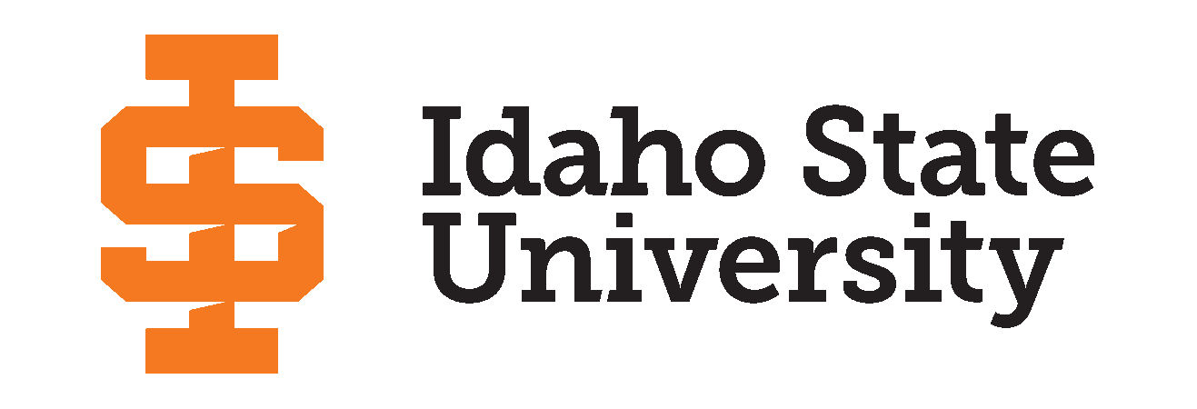

Announcing the 2023 Idaho State University’s Graduate Research Symposium Winners!

**POCATELLO, Idaho––**The Idaho State University’s Graduate School held its annual Graduate Research Symposium on Wednesday, March 15, 2023, at the Earl R. Pond Student Union building where graduate students, of all different disciplines, presented their research in a variety of categories. The ISU Graduate School has proudly hosted the Graduate Research Symposium since 2015 and will celebrate its 10-year anniversary of the event next spring.

The Graduate School was proud to feature Dr. Rob Lion, Associate Professor of Human Resource Development in the College of Education, as this year’s keynote speaker. Lion gave an inspiring and humorous speech reminding students that “work should fuel the human spirit, not drain it.”

The conference-style symposium gives students the opportunity to present their research, in progress or completed, in a 10-minute oral presentation, a poster presentation, and/or a creative work display. Students may participate in one or more of these three categories. Literature reviews, research projects, capstone projects, case studies, grant proposals, humanitarian trips, class papers, and other related scholarly or creative work all qualify as presentable research.

The subject categories include

* Biological & Natural Sciences
* Business, Economics & Public Administration
* Education, Learning Training
* Engineering, Physical & Mathematical Sciences
* Health, Nutrition & Clinical Sciences
* Humanities, Behavioral & Social Sciences
* Creative Works

Out of 61 participants, the Graduate School was pleased to award 13 students in each of these categories:

# Oral Presentation Winners -

Business, Economics & Public Administration: Madison Mancini - “Increasing Leader Member Exchange through Social Exchange Theory”

Education, Learning & Training: Danielle Fernandez - “The History of Games in Education”

Engineering, Physical & Mathematical Sciences: Olivia Stanley - “Rock Glacier Distribution and Implications for Alpine Hydrology in the Northern Rocky Mountains”

Health, Nutrition & Clinical Sciences: Arina Ranjit - “Improving Anti-Arthritic Effects of Novokinin through Bisphosphonate Conjugation”

Biological & Natural Sciences: Jeffrey Okojie - “Developing a Radioimmunotherapy for Synovial Sarcoma”

Humanities, Behavioral & Social Sciences: Jacob Harris - “The QAnon Infection: How Families Have Reacted to Members' Conspiratorial Identities”

# Poster Presentation Winners -

Biological & Natural Sciences: Brooks Myers - “Identifying Fine-Scale Qualities of Greater Sage-grouse (Centrocercus urophasianus) Habitat Using Natural Color and Multispectral UAS Imagery”

Business, Economics & Public Administration: Rian Binte Kamal - “Empirical Analysis of Triple Bottom Line Reporting in The Banking Sector and its Determinants: Focus on Environmental Issues”

Education, Learning & Training: Rifat Ara Tasnim - “An Empirical Analysis to Examine the Disparate Impact of Distinct Background Music on Gameplay Experience”

Engineering, Physical & Mathematical Sciences: Zayed Mohammad - “Slotted Waveguide for High Dielectric Heating” Health, Nutrition & Clinical Sciences: Arina Ranjit - “Improving Anti-Arthritic Effects of Novokinin through Bisphosphonate Conjugation”

Humanities, Behavioral & Social Sciences: Jessica Woolley - ‘“Tell Me a Real Story”: Motherhood and Intertextuality”

# Creative Works -

Pamela Pascali - “Idaho's Obsidian History: Tools and Technology, a learning module for 4th grade”

Congratulations to all winners, and to everyone who participated. A full list of participants and the event program can be viewed on the [Graduate School’s website](https://www.isu.edu/graduatesymposium/).

For another opportunity to learn about cutting-edge research from Idaho State graduate students, the Graduate School’s Three-Minute Thesis Competition will be held on November 9, 2023.

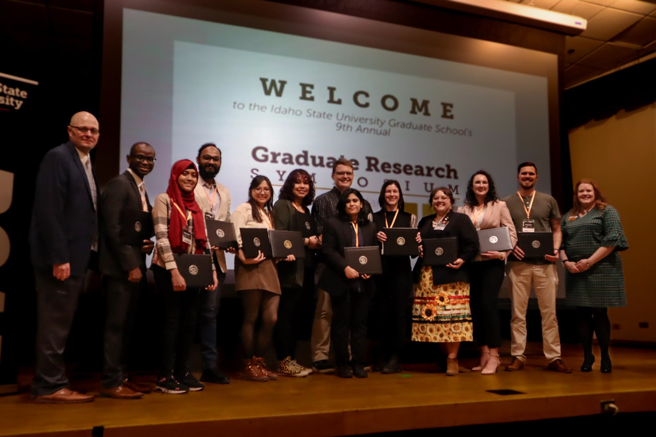

*Graduate School Dean, Dr. Adam Bradford (left), and Associate Dean, Dr.Tracy Collum, (right) with the 2023 Graduate Research Symposium winners posing with their awards.*

# # #

**Idaho State University** was founded in 1901 and has grown to be one of the most comprehensive institutions in the country. The University is one of only six institutions in the US offering programs from technical certificates through graduate and professional degrees. As the state's designated lead institution in health professions, Idaho State is home to more than 75 percent of Idaho’s health degree programs. Idaho State attracts students from around the world to its campus locations in Pocatello, Meridian, Idaho Falls, and Twin Falls. More information about Idaho State University is available at [isu.edu/about](http://www.isu.edu/about).