Disability Services



**Providing Equal Access**

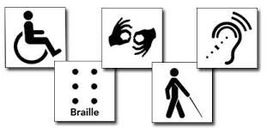

Meridian Disability Services Coordinator:

Soni Myers



# Disability

A condition that substantially limits a major life activity (ADA, Federal Law).

* Examples:
  + Visual Impairment or Blind
  + Hard of Hearing or Deaf
  + Mental Health Conditions
  + Intellectual Disability
  + Learning Disability
  + Acquired Brain Injury
  + Physical and Mobility Impairments

# Accommodations

## Students

* Fill out the Online Student Application.
* Schedule an appt.

## Employees

* Fill out the Employee Request for Services Form.
* DS will contact to schedule an appt.



[www.isu.edu/disabilityservices](http://www.isu.edu/disabilityservices)



# Communication at every stage:

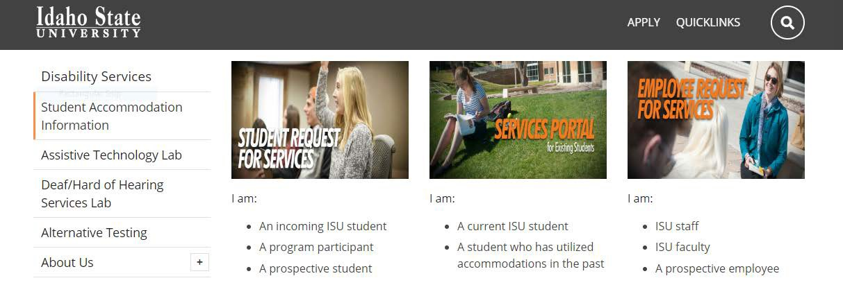

* Online
* Application
* Acceptance Letter
* Syllabus & Handbook
* NSO
* Transition from didactic to clinical
* Appeals



# When to involve us?

* Student self-reports disability
* Suspect disability
* Important decisions
* Appeal process
* Identity issues

# Top 5 Barriers

* Desire to avoid negative social reaction



* Insufficient knowledge
* Perceived quality and usefulness of services
* Negative experiences with professors

Marshak, L., Van Wieren, T., Raeke Ferrell, D., Swiss, L., & Dugan, C. (2010). Exploring barriers to college student use of disability services and accommodations. Journal of Postsecondary Education and Disability, 22(3), 151-165.

# Case Law Example

* North v. Widener University, 869 F. Supp. 2d 630 (E.D. Penn. 2012).



# What can we do?

* Provide guidance and consultation
* Support consistency
* Assist with communication
* Make determinations about reasonable accommodations



# Contact

[www.isu.edu/disabilityservices](http://www.isu.edu/disabilityservices)

Pocatello Main Office

* + Rendezvous Complex, Room 125
  + 208-282-3599
  + VP for ASL: 208-530-6505

Meridian Office

* + 208-373-1723
  + Sam & Aline Skaggs Health Science Center, Room 644b