***THE***

***GRADUATE SCHOOL*** Idaho State University

*presents*

**the 8th Annual**

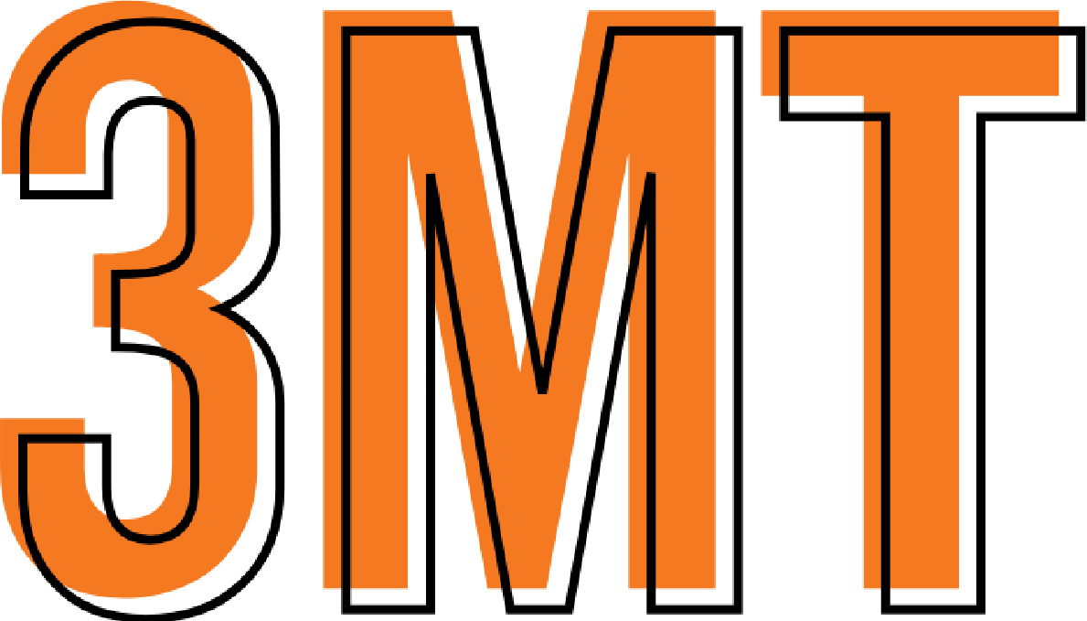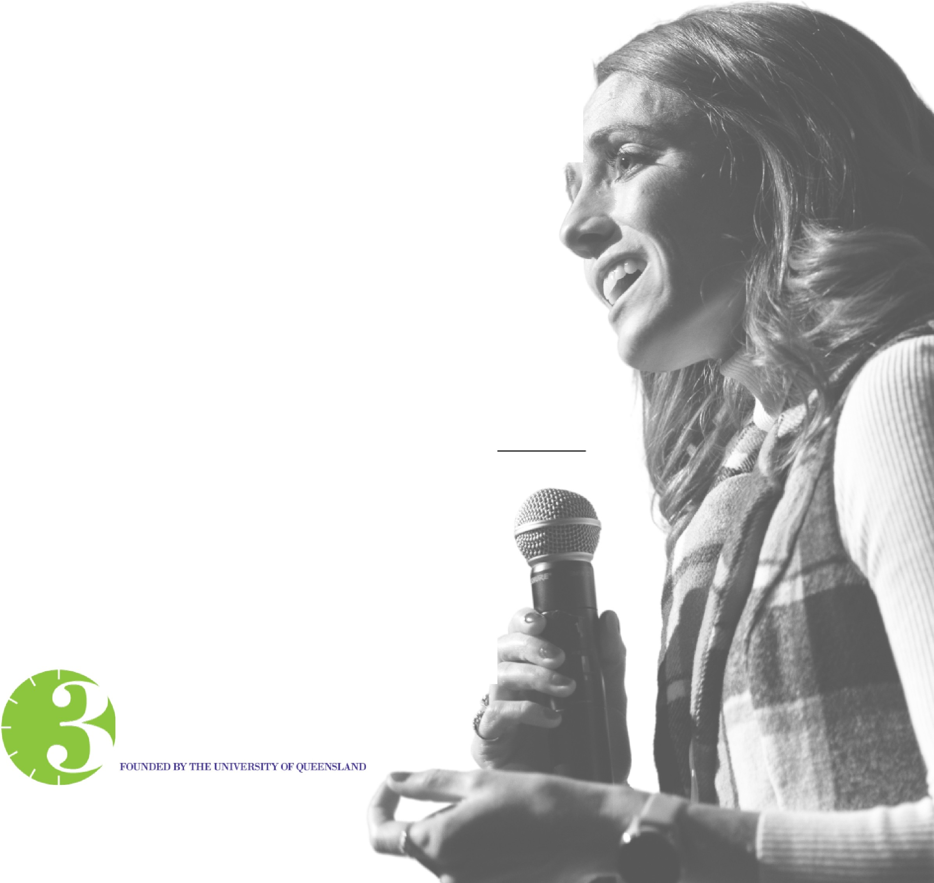

**Competition**

November 14, 2024

LE. and Thelma E. Stephens Performing Arts Center

**MT**

**®THREE MINUTE THESIS**

# Idaho State University's Land Acknowledgment Statement

Acknowledging Native lands is an important way to honor and respect Indigenous peoples and their traditional territories. The land on which Idaho State University’s Pocatello campus sits is within the original Fort Hall Reservation boundaries and is the traditional and ancestral home of the Shoshone and Bannock peoples. We acknowledge the Fort Hall Shoshone and Bannock peoples, their elders past and present, their future generations, and all Indigenous peoples, including those upon whose land the University is located. We offer gratitude for the land itself and the original caretakers of it.

As a public research university, it is our ongoing commitment and responsibility to teach accurate histories of the regional Indigenous people and of our institutional relationship with them. It is our commitment to the Shoshone-Bannock Tribes and to ISU’s citizens that we will collaborate on future educational discourse and activities in our communities.

Idaho State University

Graduate

School

CELEBRATING

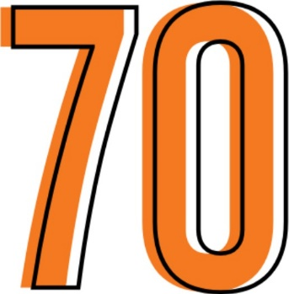 

**OF GRADUATE EDUCATION**

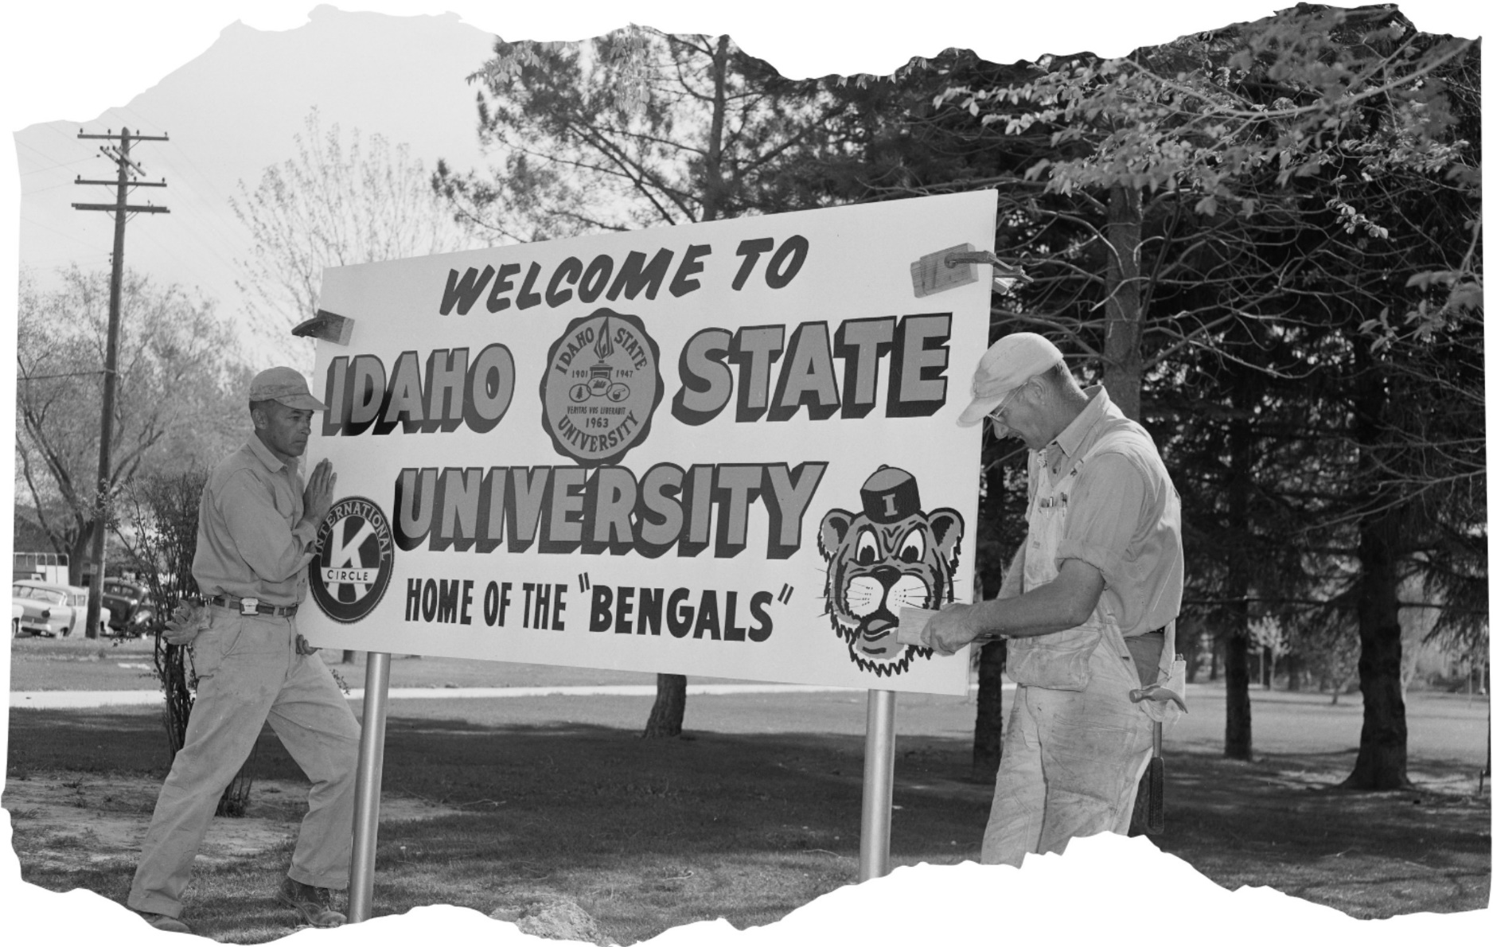

|  |  |
| --- | --- |
| **Table of Contents** |  |
| **Letter from the Interim Dean of the Graduate School** | **5** |
| **Dean’s Excellence Fund** | **6** |
| **3MT History** | **7** |
| Rules | 7 |
| Judging Criteria | 8 |
| **Meet the 2024 Judges** | **9** |
| Justin Dolan Stover | 9 |
| Michele Brumley | 9 |
| Vidya Ganji | 10 |
| Martin Blair | 10 |
| **Agenda** | **9** |
| 3MT Competition | 9 |
| Awards Reception and 70th Birthday Celebration | 14 |
| **Fall 2023 3MT Winners** | **15** |
| **Upcoming Events** | **16** |
| **Abstracts** | **17** |

# Letter from the Interim Dean of the Graduate School

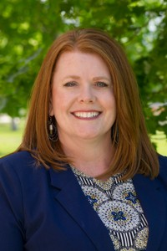

Welcome to the Graduate School's premier research event—the Three-Minute Thesis Competition (3MT)! I look forward to this event every year. The enthusiasm that students bring to the event and the pride they feel after walking off stage is immeasurable.

Our ﬁrst 3MT event began in 2018 as part of our Graduate Research Symposium. Our initial goal was to grow the number of students and the diversity of disciplines to present to a broad audience. We began with 17 students (after much recruiting) and an audience of less than 30. Our 2024 3MT received over 45 submissions with scholarly topics discussing local to global impacts.

The team at the Graduate School puts in tremendous effort to create an exceptional event for our remarkable students, and I would be remiss if I didn’t acknowledge their hard work. The faculty's enthusiasm for collaborating with graduate students has played a vital role in guiding them to this stage. Our graduate students deeply appreciate the mentorship, support, and trust they receive.

If tonight's presentations inspire you, resonate with you, or make you say "wow," we invite you to support these students and others like them by contributing to the Dean's Excellence Fund. This fund directly supports our research events and rewards students for their outstanding performances.

We are thrilled to share in your enthusiasm for the work being presented tonight, whether you are a graduate student participant, a judge, a faculty mentor, or a community member interested in our presentations. Thank you for supporting the work of graduate students at Idaho State University.

Tracy Collum

Dr. Tracy Collum

Interim Dean of the Graduate School

# Dean’s Excellence Fund

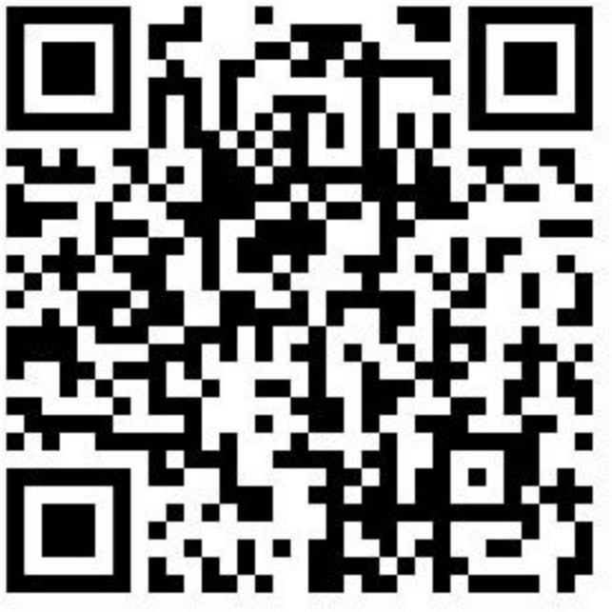

For 70 years, the mission of the Graduate School has been to promote and support excellence in graduate education. To assist in this mission, the Graduate School is afﬁliated with the Idaho State University Family of Funds through the Dean's Excellence Fund.

You can honor students for their outstanding academic and creative achievements by donating to the Graduate School's

Dean's Excellence Fund. Graduate students who place in our 3-Minute Thesis Competition and Research Symposium are eligible for cash prizes, funded in part by the Dean's Excellence Fund.

Your support of the Dean's Excellence Fund will have an immediate and direct impact on our graduate students. Your contribution will help us maintain our vision of being a leading force in high-quality graduate education. Donation amounts are ﬂexible; however, to make the most signiﬁcant positive impact on our GradBengals, we encourage you to consider setting up a recurring monthly gift.

To make a one-time or ongoing donation to the Graduate School's Dean's Excellence Fund, simply scan the QR code above.

***In celebration of 70 years of graduate education at Idaho State University, a card reader will be available at the awards reception for a special $70 gift option.***

# 3MT History

Three Minute Thesis (3MT®) is a research communication competition developed by The University of Queensland (UQ) in 2008, whereby graduate students have exactly three minutes to present a compelling oration on their thesis and its signiﬁcance. 3MT challenges students to consolidate their ideas and research discoveries so they can be presented concisely to a non-specialist audience.

Enthusiasm for the 3MT concept and its adoption in numerous universities led to the development of an international competition, of which the Graduate School has been participating in since 2018.

#### Rules

* A single static PowerPoint slide is permitted (no slide transitions, animations or 'movement' of any description, the slide is to be presented from the beginning of the oration).
* No additional electronic media (e.g. sound and video ﬁles) are permitted.
* No additional props (e.g. costumes, musical instruments, laboratory equipment) are permitted.
* Presentations are limited to 3 minutes maximum and competitors exceeding 3 minutes are disqualiﬁed.
* Presentations are to be spoken word (e.g. no poems, raps or songs).
* Presentations are to commence from the stage.
* Presentations are considered to have commenced when a presenter starts their presentation through movement or speech.
* The decision of the adjudicating panel is ﬁnal.

#### Judging Criteria

Comprehension & Content

* Did the presentation provide an understanding of the background to the research question being addressed and its signiﬁcance?
* Did the presentation clearly describe the key results of the research including conclusions and outcomes?
* Did the presentation follow a clear and logical sequence?
* Was the thesis topic, key results and research signiﬁcance and outcomes communicated in language appropriate to a non-specialist audience?
* Did the speaker avoid scientiﬁc jargon, explain terminology and provide adequate background information to illustrate points?
* Did the presenter spend adequate time on each element of their presentation

- or did they elaborate for too long on one aspect or was the presentation rushed?

Engagement & Communication

* Did the oration make the audience want to know more?
* Was the presenter careful not to trivialize or generalize their research?
* Did the presenter convey enthusiasm for their research?
* Did the presenter capture and maintain their audience's attention?
* Did the speaker have sufﬁcient stage presence, eye contact and vocal range; maintain a steady pace, and have a conﬁdent stance?
* Did the PowerPoint slide enhance the presentation - was it clear, legible, and concise?

# Meet the 2024 Judges

###### Professional portrait of Dr. Justin Dolan Stover.Justin Dolan Stover, Ph. D.

Department Chair, History; ‘23-’24 Distinguished Researcher Award

Dr. Stover is a Professor and the Department Chair of History. He holds degrees from Central Michigan University (B.S.), University College Dublin (M.A.), and Trinity College Dublin (Ph.D.). His ﬁrst book, *Enduring Ruin: Environmental Destruction during the Irish Revolution*, surveyed diverse Irish landscapes as both platforms for revolutionary revolt and victims of state retaliation. Stover’s body of scholarship has explored a variety of topics, including political prisoner culture, sexual violence in revolutionary conﬂict, and environmental destruction in war. He has undertaken several research fellowships at universities throughout Ireland, and recently concluded a sabbatical fellowship at the Netherlands Institute for Advanced Study in Amsterdam.

###### A professional portrait of Dr. Michele BrumleyMichele Brumley, Ph. D.

Associate Vice President for Research

Dr. Michele Brumley is the Associate Vice President for Research and a Professor of Psychology. Originally from Chicago, Dr. Brumley earned a B.A. in Psychology from DePaul University and a Ph.D. in Behavioral and Cognitive Neuroscience from the University of Iowa. She then completed postdoctoral research in spinal cord neurophysiology at the Miami Project to Cure Paralysis before joining the faculty at ISU. She maintains a developmental behavioral neuroscience research lab, where she collaborates with an amazing group of graduate and undergraduate students. In her administrative work in the Oﬃce for Research, Dr. Brumley helps to facilitate research activities across the university.

###### A professional portrait of Dr. Vidya Ganji.Vidya Ganji, Ph.D.

Associate Professor, Business

Dr. Ganji earned her undergraduate degree in Electronics and Telecommunication Engineering and MBA in Human Resources from India. After graduation, she started working in the industry as an HR Consultant. She has over four and half years of professional experience in Leadership Hiring, International Talent Acquisition, Executive Search, and Market Research. Dr. Ganji completed her Ph.D. in Management Science from The University of Texas at Arlington. She works as an Assistant Professor of Management at The College of Business at ISU. Her research interests are Industry 4.0, Digital Transformation, and related applications.

###### A professional portrait of Dr. Martin "Marty" Blair.Martin “Marty” Blair, Ph.D.

Vice President for Research and Economic Development

Dr. Martin Blair’s vision-driven leadership at Idaho State University builds and strengthens collaborative relationships with strategic partners in university, industry, government and philanthropic domains. He guides community-based research, training and service initiatives through collaborative strategy development, implementation and evaluation. Dr. Blair began his career as a special education teacher. Then, he spent the next two decades at the University Center for Excellence in Developmental Disabilities at Utah State University as director of numerous state and national research and training initiatives. In 2013, he assumed leadership of the University of Montana Rural Institute for Inclusive Communities. In these various roles, Dr. Blair has generated and directed over $65 million to improve the quality of services, supports and policies for individuals with disabilities and their families. He was appointed the Idaho State University Vice President for Research and Economic Development in July 2022.

# Agenda

### November 14, 2024

L.E. & Thelma E. Stephens Performing Arts Center in Pocatello, Idaho

#### 3MT Competition

Black Box Theatre

**View the** [**competition**](https://www.youtube.com/watch?v=eAknW3OcYI0) **and** [**awards reception**](https://www.youtube.com/watch?v=-jrxJ8sIObY) **virtually.**

**6:00 PM Event Introduction & Opening**

Dr. Tracy Collum, Interim Dean | Graduate School

Welcome

Dr. Adam Bradford, Interim Provost and Vice President of Academic Affairs

Three-Minute Thesis Presentations

Presenter 1 **Sharif Md Yousuf Bhuiyan**

Engineering & Applied Science - PhD

Presenter 2 **Antora Dev**

Engineering & Applied Science - PhD

Presenter 3 **Jacob McMillin**

Nursing Practice - DNP

Presenter 4 **Adam Brown**

Microbiology - MS

Presenter 5 **Rimi Das**

Electrical & Computer Engineering - MS

Presenter 6 **Miles Rhoads**

Anthropology - MS

Presenter 7 **Costain Nachuma**

Engineering & Applied Science - PhD

Presenter 8 **Rifat Ara Tasnim**

Engineering & Applied Science - PhD

Presenter 9 **Sara Sourani Yancheshmeh**

Mechanical Engineering - MS

Presenter 10 **Yvette Cadeaux**

Educational Leadership - EdD

Presenter 11 **Wesley Peterson**

Clinical Mental Health Counseling - MCoun

Presenter 12 **Tanzim Mostafa**

Computer Science - MS

Presenter 13 **Callan Norby**

Chemistry - MS

Presenter 14 **Md Mosharaf Hossan**

Computer Science - MS

Presenter 15 **John Opeifa**

History - MA

Presenter 16 **Holly Kartchner**

Political Science - DA

Presenter 17 **Arifa Islam Champa**

Engineering & Applied Science - PhD

Presenter 18 **Dallin Stokes**

Microbiology - MS

Presenter 19 **Modupeola Bada**

Communication - MA

Presenter 20 **Mikayla Macaluso**

Biology - MS

Presenter 21 **Val Kimbrough**

Computer Science - MS

Presenter 22 **Julia Duran**

Clinical Psychology - PhD

Presenter 23 **Shijon Das**

Computer Science - MS

Presenter 24 **Vanessa Gallegos**

Public Health - MPH

Presenter 25 **Md Fazle Rabbi**

Engineering & Applied Science - PhD

Presenter 26 **Joseph Orr**

History - MA

Presenter 27 **Bailey Bresee**

Microbiology - PhD

Presenter 28 **Amir Hafezi**

Mechanical Engineering - MS

Presenter 29 **Fatemeh Falahati Marvast**

Biology - MS

Presenter 30 **Kelli Rich**

Nursing Practice - DNP

Presenter 31 **Lauren Elmore**

Clinical Psychology - PhD

Presenter 32 **Eliana Claps**

Clinical Psychology - PhD

Presenter 33 **Alicia Pino**

Business Administration - MBA

Closing Remarks

Dr. Tracy Collum, Interim Dean | Graduate School

### Vote for the People’s Choice Award

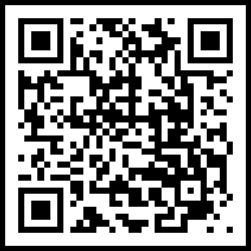

Scan the QR code with your photo app and make your selection.

<https://isu.co1.qualtrics.com/jfe/form/SV_56z7L5jwo8lL3U2>

#### Awards Reception and 70th Birthday Celebration

Rotunda

Opening

Dr. Tracy Collum

Interim Dean | Graduate School

Winners Announced

Anna Siddoway

Interim Director | Graduate School

Reception

*Enjoy libations & hors d'oeuvres*

***Sonitus Trio***

School of Performing Arts | Department of Music

**Joseph Bounmixay** *Violin*

College of Health Minor in Music

**Sharon Winters** *Viola* Associate of Science in Mathematics

**Ian Woodruff** *Cello*

Bachelor of Arts in Music

# Fall 2023 3MT Winners

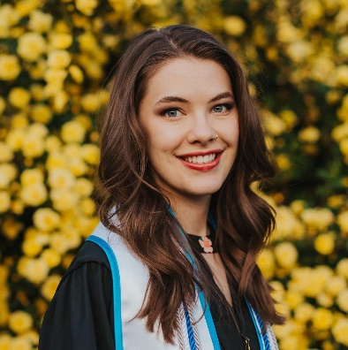

**1st Place**

###### Dawn Amos

Public Health - M.P.H.

***Predictors of Unintended Pregnancy and STI Co-Occurrence***

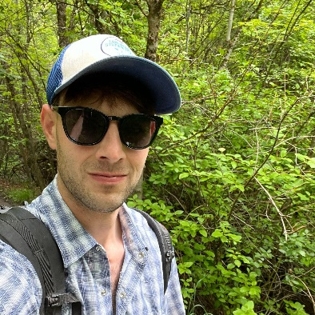

**2nd Place**

###### Adam Zambie

Biology - M.S.

***How Much Stream is Enough? Does Amount of Remnant Habitat Predict a Decline in Genetic Diversity for Redband Trout Populations***

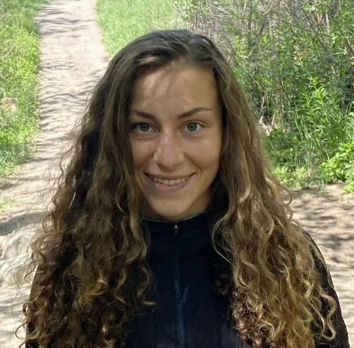

**3rd Place**

###### Bethany Hickey

Nutrition - M.S.

***Food Processing and Appetite Regulation: How Ultra-Processed Foods May Be Inﬂuencing What and How Much We Eat***

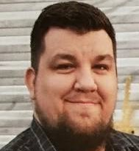

**People’s Choice Award**

###### Verlyn Glenn

Nursing Practice - D.N.P.

***Barriers To Nurse Practitioner Post-graduate Fellowships***

# Upcoming Events

## State Three-Minute Thesis Competition

February 2025, Livestreamed via YouTube Live

## 2025 Research & Creative Works Symposium

Wednesday, March 19, 2025, Earl R. Pond Student Union, Pocatello, Idaho

## Late Nights with the Graduate School

Friday, December 6, 2024 | 7:00 p.m. - 9:00 p.m.

ISU Games Center | 1065 Cesar Chavez Ave, Pocatello, Idaho

## Summer Funding Deadline April 30, 2025

Summer funding is available for graduate students to support research, creative activities, and thesis and dissertation workshops.

# Abstracts

##### Sharif Md Yousuf Bhuiyan

Engineering & Applied Science - PhD

***"High-Temperature Steam Electrolysis (HTSE): Development of Support Facilities System of Various Test Plants"***

This project developed an automated high-temperature steam electrolysis (HTSE) system for hydrogen production at Idaho National Laboratory. Key tasks included control system design, user interface creation, and testing for enhanced hydrogen recycling, de-ionized water production, and operational eﬃciency. Challenges like high-temperature material degradation, energy eﬃciency, and scalability were addressed to advance HTSE technology, paving the way for sustainable industrial applications and integration with renewable energy sources.

##### Antora Dev

Engineering & Applied Science - PhD

***"Automated Phenotyping of Herbaceous Biomass Using U-Net Architecture for µ-CT Images Segmentation"***

Understanding vascular bundles in biomass is important for biomass production and biofuel eﬃciency. Micro-computed tomography (µ-CT) can provide important insights but generates a low structural contrast that causes noise and often demands time-consuming segmentation procedures. To automatically segment vascular bundles, we use the U-Net deep learning model. Preprocessing with adaptive thresholding and morphological operations, our strategy achieved 97.98% test accuracy, enhancing phenotyping eﬃciency and advancing biofuel innovation.

##### Jacob McMillin

Nursing Practice - DNP

***"Community Movie Screening: Assessing Advance Care Planning Readiness"***

The majority of adults are not ready to engage in conversation around the subject of advance care planning. Improving the readiness to engage in these conversations is a necessary ﬁrst step to getting more adults to pursue advanced care planning. The purpose of this project is to improve the readiness of adults by encouraging them to engage in discussion about advance care planning through the intervention of a community event. This hopefully prevents that lack of awareness and educates people on how they can direct their healthcare.

##### Adam Brown

Microbiology - MS

***"The Hidden Promoter of Bacteriophage 80α and How to Activate It: How to Possibly Bypass Antibiotic Resistance in Staphylococcus Aureus"***

Bacteriophages are viruses that infect bacteria and hijack the host's molecular machinery. SaPIs are pathogenicity islands that hijack machinery from bacteriophages. This interesting interaction, in particular a certain protein from SaPI1 interacting with bacteriophage DNA, may hold the secrets to clearing problematic Staphylococcus aureus infections such as MRSA. An alternative to typical antibiotics is needed for many multi-drug resistant infections, and this could be the new path forward.

##### Rimi Das

Electrical & Computer Engineering - MS

***"Highly Directional Antenna at Ultra-High-Frequency Bandwidth"***

My research focuses on synthesizing a unidirectional antenna essential for satellite & radar communication, military, and defense applications. In this era of technology, securely sending information over a distance is a concern, and this antenna can play a vital role in communicating in a ﬁxed direction. It comprises a spiral antenna and reﬂect array that maintains high directivity. The study presents antenna design, simulation, and performance evaluation, explaining possible usability in various applications in today's communication systems.

##### Miles Rhoads

Anthropology - MS

***"Ethical and Equitable Creation of Closed Missing Persons Cases Database: Utilizing Intersectional Theories”***

Native American communities are disproportionately affected by the Missing and Murdered Indigenous People (MMIP) crisis, yet many cases remain underreported. This research creates a culturally sensitive database of closed missing persons cases in Idaho, particularly along the

I-15 corridor. By gathering overlooked cultural and geographic data, this study aims to improve recovery efforts for law enforcement and advocates, with broader implications for public awareness and search outcomes.

##### Costain Nachuma

Engineering & Applied Science - PhD

***"Privacy and Security for LLMs and LMMs Across Key Sectors"***

The integration of Large Language Models (LLMs) and Large Multimodal Models (LMMs) has not only enhanced education, healthcare and ﬁnance by offering innovative solutions but also introduced signiﬁcant security and privacy risks. We analyze these challenges such as data breaches, biases in decisions, and adversarial attacks. We propose mitigation strategies including differential privacy, federated learning, and robust model monitoring to ensure safe adoption of AI across diverse sectors.

##### Rifat Ara Tasnim

Engineering & Applied Science - PhD

***"The Impact of Serious Games to Facilitate the Eﬃcacy of Psychotherapeutic Techniques"***

With the rapid changes in social dynamics, the number of individuals affected by mental illness is rising. For those who avoid traditional treatment for shyness or stigma, serious games offer a feasible alternative by delivering treatment in a more engaging and personal way. A serious game is just like a regular video game but developed to achieve an additional goal along with entertainment. Our research outcome demonstrated serious games' effectiveness in adopting psychotherapeutic techniques.

##### Sara Sourani Yancheshmeh

Mechanical Engineering - MS

***"Optimizing Chassis Design for Autonomous Vehicles in Challenging Environments Based on Finite Element Analysis and Genetic Algorithm"***

The demand for autonomous vehicles in challenging terrains has led to innovative chassis design solutions. This study presents a chassis optimized for quadcopter charging, balancing structural integrity and weight eﬃciency. Using Finite Element Methods and MATLAB, optimal mass and length parameters were derived, ensuring robustness and minimal material usage. The results offer a sustainable solution for rough terrain navigation, advancing autonomous vehicle design for specialized environments.

##### Yvette Cadeaux

Educational Leadership - EdD

***"Postcards from the Pandemic: Perceptions of K-12 Remote Instruction and Post-Secondary Choices"***

This study will explore the perspectives of adults who participated in emergency remote instruction as youth during the COVID-19 pandemic. The study’s purpose is to examine attitudes toward remote instruction and online learning and determine how those perceptions shape

post-secondary decision-making, speciﬁcally the decision to enroll in online college classes or an online degree program. The ﬁndings produced by this study can impact planning decisions made at post-secondary institutions.

##### Wesley Peterson

Clinical Mental Health Counseling - MCoun

***"Integrating Yoga Nidra as a Trauma Intervention for Incarcerated Women"***

Idaho incarcerates women at a higher rate than any other state in the United States. Treating trauma may be key for efforts in crime prevention, rehabilitation, and reducing recidivism rates of incarcerated women. Richard Miller adapted the practice of yoga nidra for military veterans with PTSD through his iREST program. Empirical evidence supports those efforts in treating trauma symptomology. The purpose of my current project is adapting the yoga nidra practice in conjunction with group therapy for incarcerated women.

##### Tanzim Mostafa

Computer Science - MS

***"Transforming Critical Materials Exploration with Machine Learning"***

Critical materials like cobalt, lithium, and rare earth elements are essential for modern technology but are increasingly diﬃcult to ﬁnd. My research leverages machine learning to analyze geoscientiﬁc data and predict mineral deposits with greater accuracy. This approach improves exploration eﬃciency, reduces environmental harm, and promotes ethical sourcing, offering a sustainable solution to meet the growing demand for these vital resources.

##### Callan Norby

Chemistry - MS

***"Novel Sulfur-Rich Hydrogels and Their Applications in Agriculture"***

Sulfur depletion, which can result in the buildup of pesticides and other toxic chemicals in soil, is currently a growing problem in American agriculture. This issue has triggered a rapid increase in the development and use of sulfur-based fertilizers in the United States. Using a novel type of green sulfur chemistry, we have developed a high sulfur content hydrogel that shows promise in not only delivering sulfur to soil, but also aiding in water retention and microbial health.

##### Md Mosharaf Hossan

Computer Science - MS

***"Can You Keep Calm?: Interactive Gameplay with Heart Rate as the Controller”***

Serious games are being used in mental health interventions, offering accessible therapeutic environments through smartphones and smartwatches. This thesis introduces a game to help players manage stress by adjusting gameplay based on heart rate. We assessed how heart rate-based controls affect the experience in challenging environments. The experiment showed reduced negative emotions and increased positive ones, highlighting its potential for mental health support.

##### John Opeifa

History - MA

***"Ọmọ Kaarọ Oojire: The Impacts of Globalization on Yoruba Diaspora Communities in the Postmodern United States 1970-1999"***

This thesis examines the migration and cultural dynamics of Yoruba communities in the U.S. from 1970 to 1999, focusing on how globalization inﬂuenced cultural preservation, economic empowerment, and transnational networks. It investigates the strategies Yoruba people employ to maintain their cultural identity and adapt to the socio-economic challenges of integration into

U.S. society. A mixed-methods approach, including inter-library resources and interviews, is used to analyze these dynamics.

##### Holly Kartchner

Political Science - DA

***"Is This Really the American Dream? The Redlining of Southeast Idaho Rural Public School Students"***

Education is the gateway to the American Dream and students in rural communities should not be denied access based on where they live, especially in rural Southeast Idaho. Access includes the ability to take dual credit courses utilizing state Fast Forward funding. Redlining, the discriminatory practice that refused ﬁnancial assistance to areas in the 1930’s, is now illegal.

Today however, redlining may be considered limiting educational opportunities for students in rural Southeast Idaho. My research focuses on educational redlining.

##### Arifa Islam Champa

Engineering & Applied Science - PhD

***"Beyond the Hype: A Reevaluation of Effectiveness of Machine Learning and Deep Learning in Phishing Email Detection"***

Despite claims of machine learning (ML) and deep learning (DL) effectiveness in phishing email detection, millions still fall victim. In this study, we reassess the performance of three ML algorithms and ﬁve DL architectures across nine curated datasets. Results show a signiﬁcant decrease in model performance on previously unseen and recent phishing emails, highlighting the challenge of generalizing learned patterns to novel attacks. We recommend strategies to improve the robustness of detection systems to address gaps in current approaches.

##### Dallin Stokes

Microbiology - MS

***"Overwriting Code: TwinPE in Malaria Parasites"***

Severe malaria caused by the parasite Plasmodium falciparum is a major health burden throughout the world. To better treat this disease, we must ﬁrst expand our understanding of the parasite’s gene expression pathways. TwinPE is a technique for deleting a small portion of a genome and replacing it with different genomic code. This technique, never before used in P. falciparum, could be used to append ﬂuorescent tags to the end of nuclear genes, enabling the study of their expression patterns.

##### Modupeola Bada

Communication - MA

***"The Public Discourse: What Does the AI Revolution Mean for Our Future?"***

This study uses Habermas's public sphere theory to 1) analyze the discourse on artiﬁcial intelligence and 2) identify patterns of topics and concerns. Using Communalytics, a data analysis program, the study extracts comments from two videos that discuss AI. The qualitative analysis reveals themes that include societal implications of AI development. This study connects the discourses to Habermas's notion of the public sphere as a space for democratic discussion. The ﬁndings offer insights into public attitudes and concerns about AI.

##### Mikayla Macaluso

Biology - MS

***"Investigating Bricks in Early Craniofacial Development”***

3 MC syndrome is a developmental disorder caused by a mutation in the mannan-binding lectin serine protease 1 (Masp1) gene. Human patients with this syndrome have both craniofacial malformations and learning disabilities. In previous work Masp1 has been shown to affect craniofacial structures. Using African clawed frog embryos, I am investigating what cell types and structures are affected when Masp1 function is changed. This will further advance the knowledge of this genetic disorder.

##### Val Kimbrough

Computer Science - MS

***"If Superintelligence Goes Rogue: Is All Hope Lost?"***

If artiﬁcial superintelligence (ASI) goes rogue, misaligns with human intentions, and Skynet becomes a reality, is all hope lost? I’m here to say: there’s a Plan B. But the results aren’t guaranteed, and our window of opportunity may be brief. My solution? An AI-enhanced cyberattack designed to counter ASI—a last line of defense for humanity.

##### Julia Duran

Clinical Psychology - PhD

***"The Need for Resources: Severe Psychopathology in Adults With Autism Spectrum Disorder"***

The current study provided a comprehensive evaluation of psychopathology in a group of autistic adults by examining their self-reported ratings of 43 different personality traits and symptoms. Findings show clinically elevated scores in regard to emotional/internalizing dysfunction including higher levels of anxiety, depression, somatization, behavior-restricting fears, cognitive problems, suicidality, and more. Overall, we established a pattern of common psychopathology in autistic adults which may be used to guide treatment interventions.

##### Shijon Das

Computer Science - MS

***"Powering the Future: How AI is Transforming Sustainable Energy"***

As the world faces the growing threat of climate change, the transition to sustainable energy has never been more critical. My research focuses on using artiﬁcial intelligence to optimize the eﬃciency of renewable energy systems such as wind and solar power. By harnessing AI’s ability to analyze vast amounts of data in real time, we can predict energy demands, improve storage systems, and reduce waste. These advancements will not only help reduce our carbon footprint but also make renewable energy more reliable and accessible to everyone.

##### Vanessa Gallegos

Public Health - MPH

**"Salud Southeast Idaho"**

Latinos make up the largest minority group in Idaho, and make up approximately 19% of the state's population. Services need to reﬂect the demographics. Salud Southeast Idaho(SSI) is an easily accessible online Facebook page that works to promote optimal health and wellness for Latinos in Southeast Idaho. All evidence-based content created and shared on SSI is provided in BOTH Spanish and English. Collaboration is a key component of SSI success, as it breaks down barriers, builds trust, and increases creativity.

##### Md Fazle Rabbi

Engineering & Applied Science - PhD

***"Fact or Fiction: Do SBOM Tools Truly Identify Software Components and Vulnerabilities?"***

In this study, we conduct a comparative analysis of several Software Bill of Materials (SBOM) tools, examining their effectiveness in detecting software components, versions, and dependencies. The study provides insights into how SBOM tools can be used more effectively to enhance software supply chain security. Our evaluation highlights both the advantages and limitations of these tools, offering a clearer understanding of their role and impact in the current cybersecurity environment.

##### Joseph Orr

History - MA

***"Helen Keller Was a Monster and Here's Why"***

Keller is arguably the most well-known disabled person in American History. Her story of learning to communicate is the stuff of legend. Despite her impairments, her sex, and the era she lived in, Keller was praised for her intellectual prowess, and her advocacy for people with disabilities. What’s less well known is the story of how Keller used her inﬂuence to stab those same people in the back. This is the story of how Keller sold out the most vulnerable members of society.

##### Bailey Bresee

Microbiology - PhD

***"Playing Tag in the Powerhouse of the Cell"***

The malaria parasite Plasmodium falciparum has gained drug resistance to known antimalarial agents and creates a serious bottleneck for malaria control. The mitochondrion is a validated drug target and essential to the parasite’s survival. There is a mitochondrial RNA polymerase which transcribes the genes essential to the mitochondrion. Proximity-dependent biotinylation in combination with liquid chromatography and mass spectrometry is being used in this study. The results of this research are to ﬁnd new conserved drug targets.

##### Amir Hafezi

Mechanical Engineering - MS

***“The Droat”***

The Droat, developed as part of my thesis project, is a hybrid drone-boat capable of gliding across water surfaces by adjusting its propeller’s direction. This innovative quad-copter performs 3D scanning of waterbeds, providing valuable insights for underwater ecosystem analysis, resource mapping, and environmental monitoring. Additionally, it is designed to monitor aquatic life and assist in sustainable ﬁshing. Its scalable design opens up future applications, including advanced human transport solutions.

##### Fatemah Falahati Marvast

Biology - MS

***"Diagnosing Genes Affecting Cleft Palate and Lip"***

I’m exploring two genes, Hic1 and Hic2, to see how they help shape our faces as we develop. These genes guide cells as they move and grow into essential facial structures, like the bones in our faces. By understanding how these genes work, I hope to ﬁnd clues to conditions like cleft palate and cleft lip, as well as insights into diseases like cancer. Ultimately, this research could pave the way for new ways to prevent or treat these issues, making a real difference in people’s lives.

##### Kelli Rich

Nursing Practice - DNP

***"Teen Mental Health in the Age of Social Media"***

My project initiative explores the impact of social media on teen mental health, focusing on the vulnerabilities of adolescent brain development. Research shows that platforms emphasizing appearance and status can harm self-esteem, especially during critical periods like synaptic pruning. The project educates parents and communities, advocating for delaying social media use until age 16 and promoting strategies that support healthy development, aiming to create environments that foster positive mental health in teens.

##### Lauren Elmore

Clinical Psychology - PhD

***"Perceived Program Support and Coping Styles as Moderators of Graduate Student Academic Burnout"***

Academic burnout is a major stressor for graduate students, and the ﬁnancial strain associated with graduate school may play a signiﬁcant role in burnout. Both perceptions of program support and student coping styles may moderate the stress of the graduate school experience. Study ﬁndings provide data from 223 psychology graduate students on the relationship between ﬁnancial distress and academic burnout, along with how perceived program support and coping styles moderate this relationship.

##### Eliana Claps

Clinical Psychology - PhD

***"Suicidal Ideation and Perceived Program Support Among Clinical and Counseling Psychology Doctoral Students"***

Psychology trainees encounter various academic, clinical, psychosocial, and ﬁnancial stressors known to increase suicidal ideation. Perceptions of program support may be a critical protective factor. Results of the present study provide data from 223 trainees on the relationship between perceptions of program support and suicidal ideation during graduate school and how components of the interpersonal theory of suicide (i.e., hopelessness, perceived burdensomeness, and thwarted belongingness) mediate this relationship.

##### Alicia Pino

Business Administration - MBA

***"Remote Work's Hidden Challenge: How Leaders Stay in Touch Without Being in Touch"*** The rapid shift to remote work has made it critical to understand how leaders can effectively seek feedback in a transformed environment. Studies show that leaders who seek feedback are

more effective, yet the virtual setting disrupts casual, in-person exchanges that foster openness.

Our research, based on interviews, reveals that leaders now need fresh feedback approaches—ones attuned to subtle cues now infrequent and often limited to formal meetings—since organic conversations that once gauged team morale have diminished.

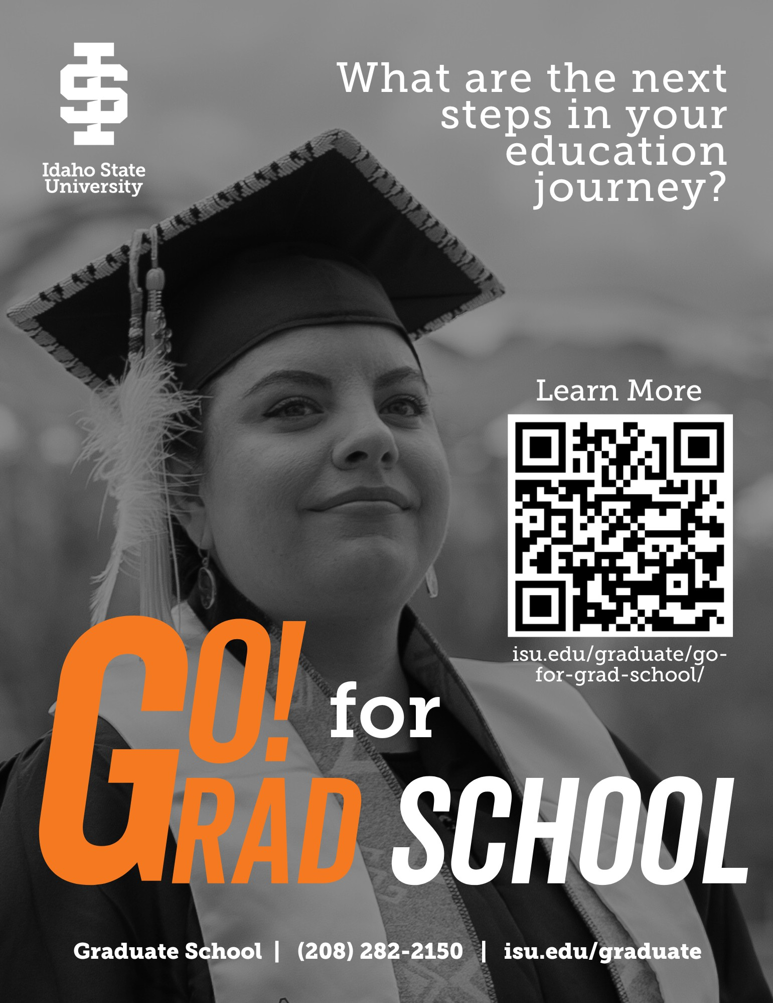

Graduate School [gradschool@isu.edu](mailto:gradschool@isu.edu) isu.edu/graduate