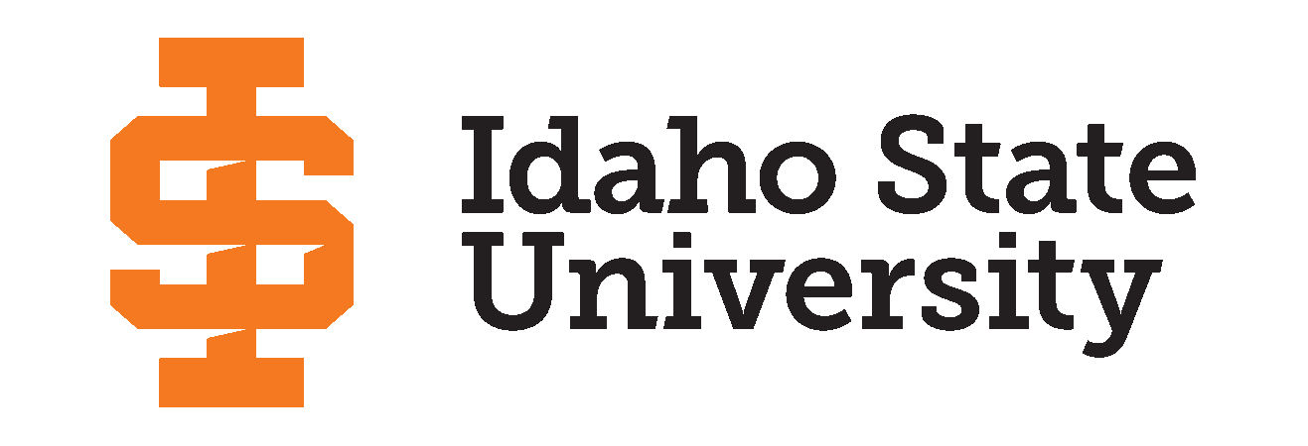

Announcing the 2024 Idaho State University’s Research and Creative Works Symposium Winners

**POCATELLO, Idaho––**Idaho State University hosted the first Research and Creative Works Symposium on Wednesday, March 13, 2024, at the Earl R. Pond Student Union building, and at the Sam and Aline Skaggs Health Science Center in Meridian, Idaho, where a combination of undergraduate and graduate students displayed and presented their research and creations. Students expressed anxiety and excitement at the prospect of presenting their hard work to gain invaluable experience and potentially win a cash prize.

The conference-style symposium is designed to allow students to present their research, in progress or completed, in a 10-minute oral presentation, a poster presentation, and/or a creative work display, of which they may participate in one or more of these categories. The coveted awards are $1,000 cash prizes granted to the winning presenters in each category.

The subject categories include:

* Biological & Natural Sciences
* Business, Economics & Public Administration
* Education, Learning Training
* Engineering, Physical & Mathematical Sciences
* Health, Nutrition & Clinical Sciences
* Humanities, Behavioral & Social Sciences
* Creative Works

Out of over 140 participants, ISU was pleased to award 13 graduate students, and two undergraduate students in each of these categories:

*Oral Presentations* -

* Christopher Nicolet - Graduate; Biological & Natural Sciences
* Rian Binte Kamal - Graduate; Business, Economics & Public Administration
* Tingxuan Lu - Graduate; Education, Learning, & Training
* Costain Nachuma - Graduate; Engineering, Physical & Mathematical Sciences
* Blair Richlin - Graduate; Health, Nutrition & Clinical Sciences
* Angelina Conrow - Graduate; Humanities, Behavioral & Social Sciences
* Sydnee Thomas - Undergraduate; Humanities, Behavioral & Social Sciences

*Creative Works* -

* Yidan Guo - Graduate

*Poster Presentations* -

* Morgan Musquez - Graduate; Humanities, Behavioral & Social Sciences
* Emily Harames - Graduate; Health, Nutrition & Clinical Sciences
* Daliedmarie Delgado Maisonet - Graduate; Engineering, Physical & Mathematical Sciences
* Jessica Woolley - Graduate; Education, Learning & Training
* Rian Binte Kamal - Graduate; Business, Economics & Public Administration
* Makenzie Reed - Graduate; Biological & Natural Sciences
* Mya McHugh - Undergraduate; Biological & Natural Sciences

While diverse research days have been hosted across ISU for over a decade, including KDHS Research Day, Undergraduate Research Day, and the Graduate Research Symposium, this year a combined event encompassed a wide range of scholarly work from all across campus. Combined with ISU’s annual Bengal Giving Day, the symposium hosted a large crowd, with over 140 presentations, oral and poster, over 60 judges, 30 volunteers and event staff, and dozens of attendees.

The event consisted of a luncheon for the participants and words of encouragement from the interim dean of the Graduate School, Dr. Tracy Collum, followed by the first round of presentations. Judges attended graduate oral presentations and chatted with undergraduates about their posters. Graduates and undergraduates then switched from oral and poster presentations, respectively, while the creative works were displayed and judged. The event concluded with an inspiring speech from keynote speaker, Dr. Cathleen Tarp, a Professor in the Department of Global Studies and Languages, and the awards ceremony.

Congratulations to all winners, and to everyone who participated. A full list of participants and the event program can be viewed on the [Graduate School’s website](https://www.isu.edu/researchsymposium/).

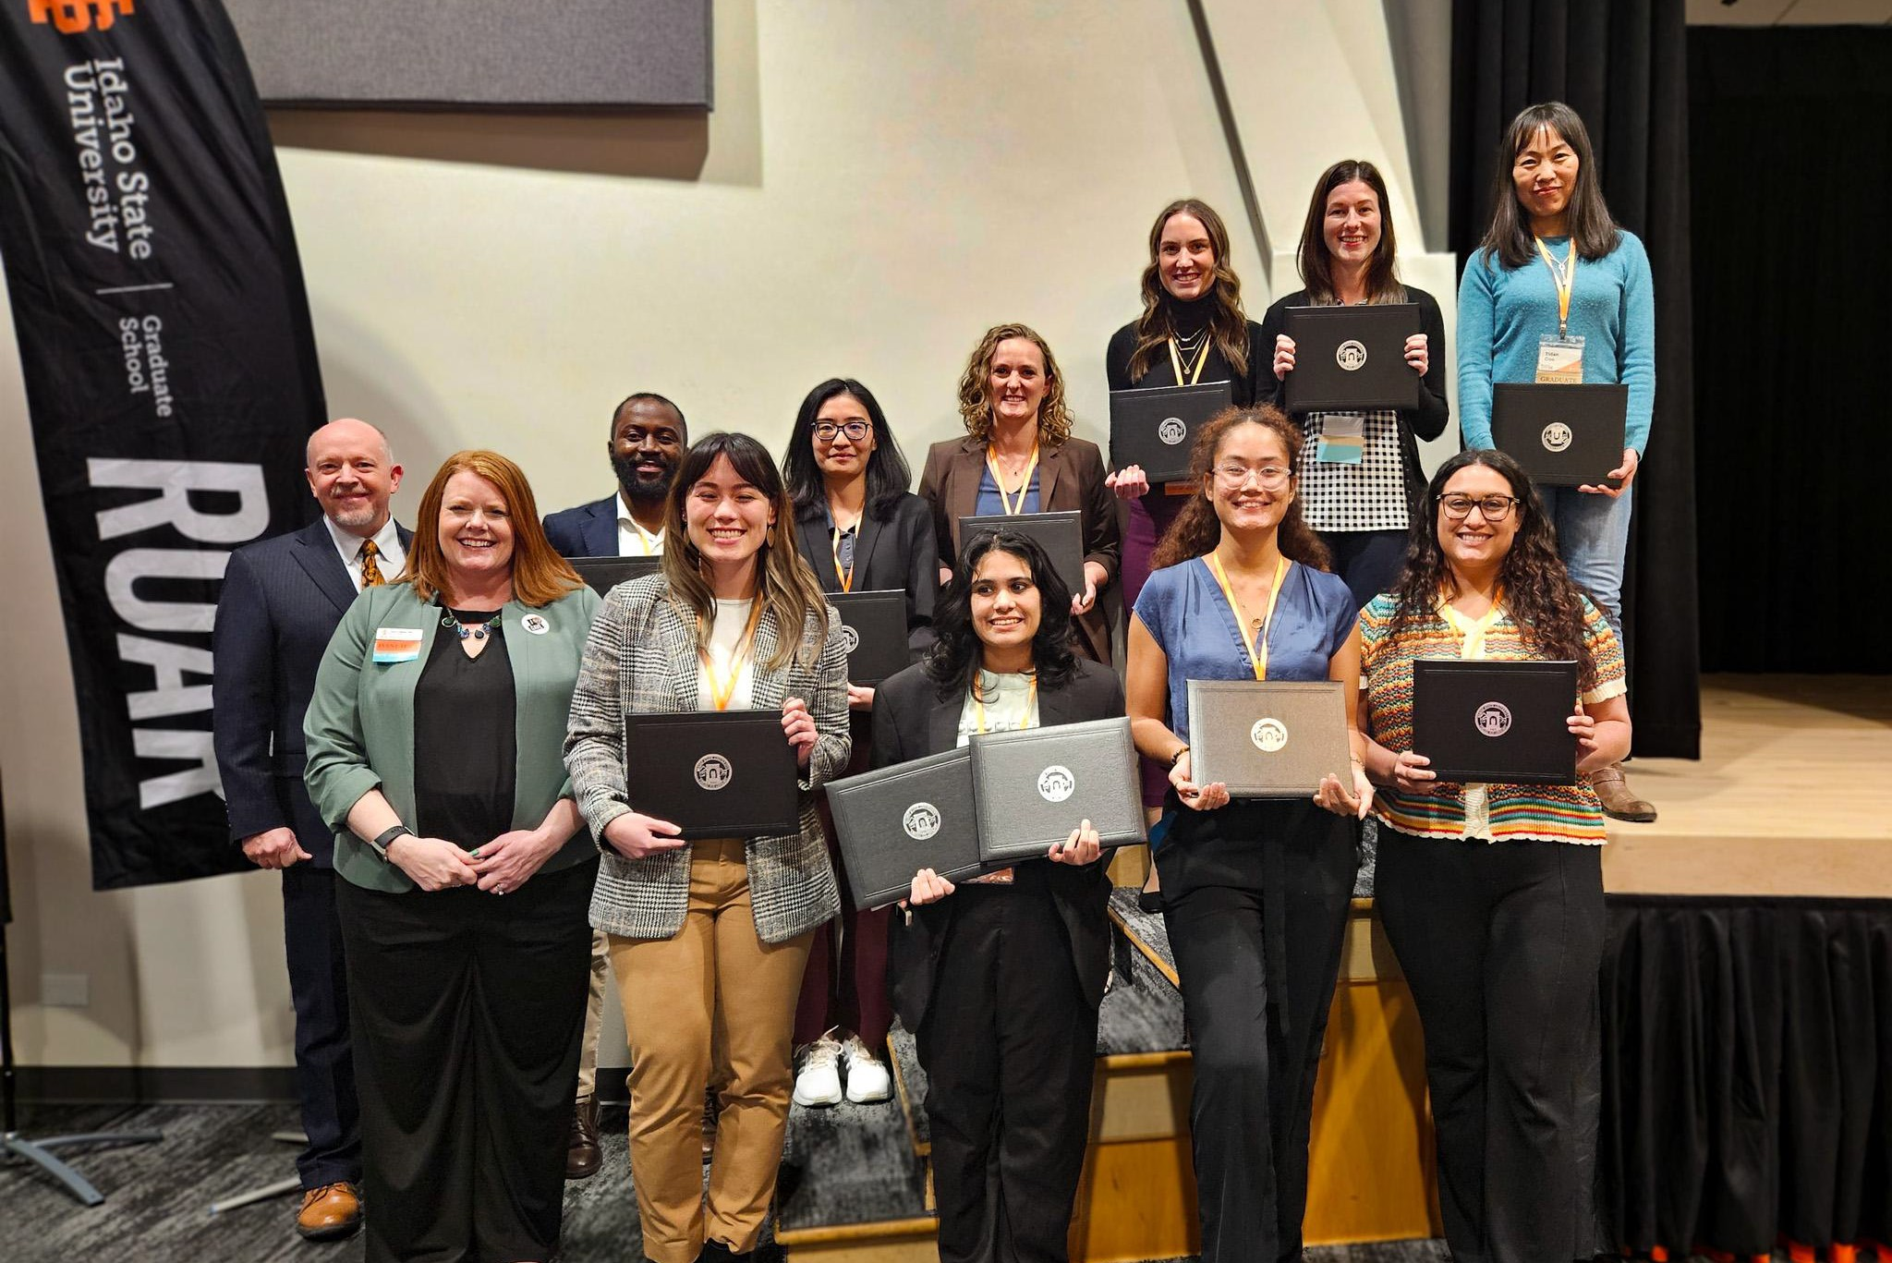

*Interim Graduate School Dean, Dr. Tracy Collum (left), and Vice President of the Office of Research, Dr.Martin Blair, (left back) with 2024 Research Symposium winners present for the awards ceremony.*

# # #

**Idaho State University** was founded in 1901 and has grown to be one of the most comprehensive institutions in the country. The University is one of only six institutions in the US offering programs from technical certificates through graduate and professional degrees. As the state's designated lead institution in health professions, Idaho State is home to more than 75 percent of Idaho’s health degree programs. Idaho State attracts students from around the world to its campus locations in Pocatello, Meridian, Idaho Falls, and Twin Falls. More information about Idaho State University is available at [isu.edu/about](http://www.isu.edu/about).