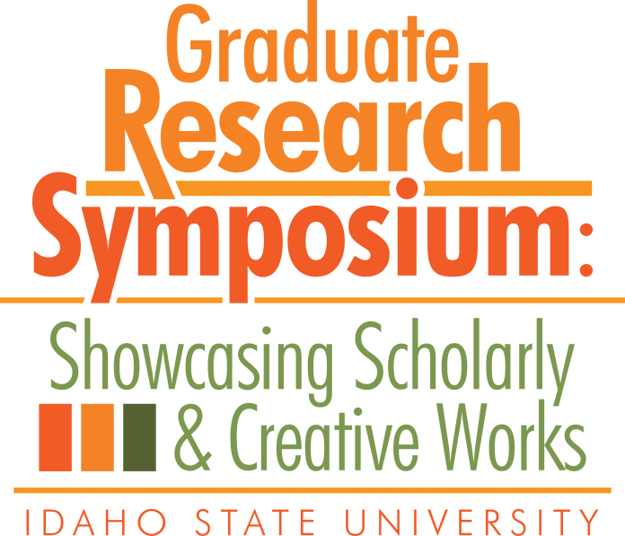

Congratulations to the

2018 Graduate Research Symposium Award Recipients!

* 3MT:
  + 1st Place: Jonathan Goode
  + 2nd Place: Nirmeet Adhvaryu
  + 2nd Place: Jessica Whitaker-Fornek
* Poster Symposium:
  + Biological & Natural Sciences: Kayla Glossner
  + Education, Learning, and Training: Leila Riley
  + Engineering, Physical, & Mathematical: Utsa Rashique
  + Health, Nutrition, & Clinical Sciences: Jeanna Ritter
  + Humanities, Behavioral, & Social Sciences: Sheherezade Krzyzaniak
  + People’s Choice Poster: Nirmeet Adhvaryu
* Oral Presentation:
  + Biological & Natural Sciences: Carolyn Macek
  + Business, Economics, and Public Administration: Hassan Afzal
  + Education, Learning & Training: Jonathan Lord
  + Engineering, Physical, and Mathematical Sciences: Landon Bayless-Edwards
  + Humanities, Behavioral, and Social Sciences: Paul Williams