# Login and ISU's SSO

Open your browser of choice and navigate to <https://Isu.edu/disabilityservices>

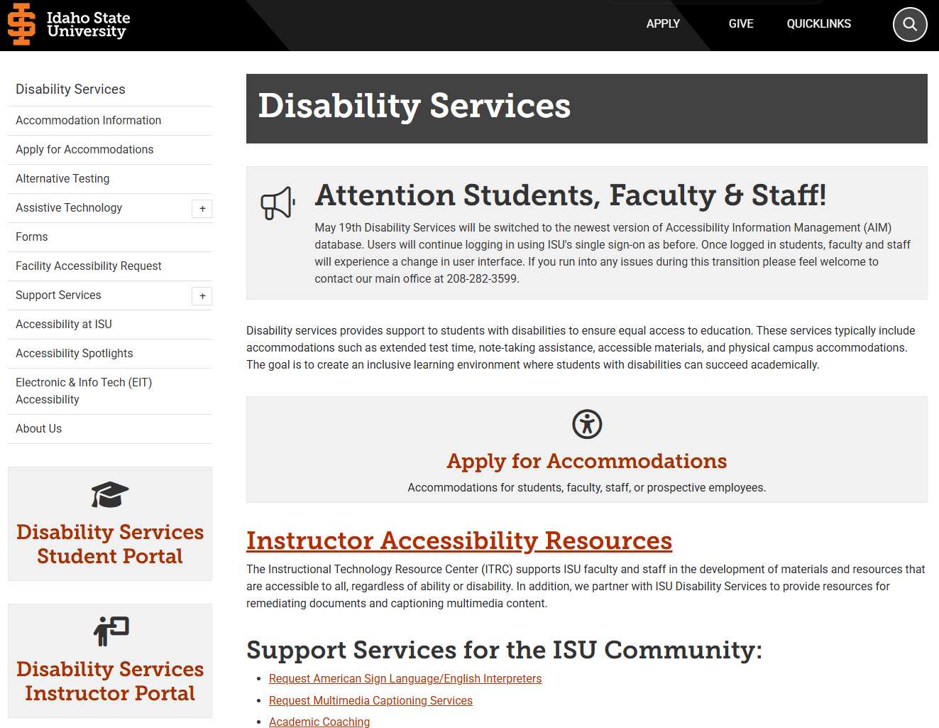

Click on [**Disability Services Student Portal**](https://denali.accessiblelearning.com/ISU/Instructor/Login.aspx).

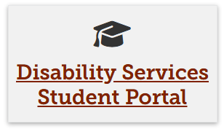

Sign in to ISU's Single Sign-On (SSO) portal & follow the prompts.

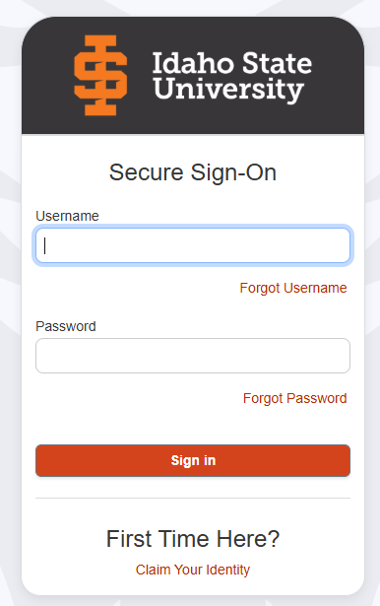

Once logged in, you are directed to your student portal dashboard, which displays your accommodation and your advisor's contact information and a menu containing a list of options.

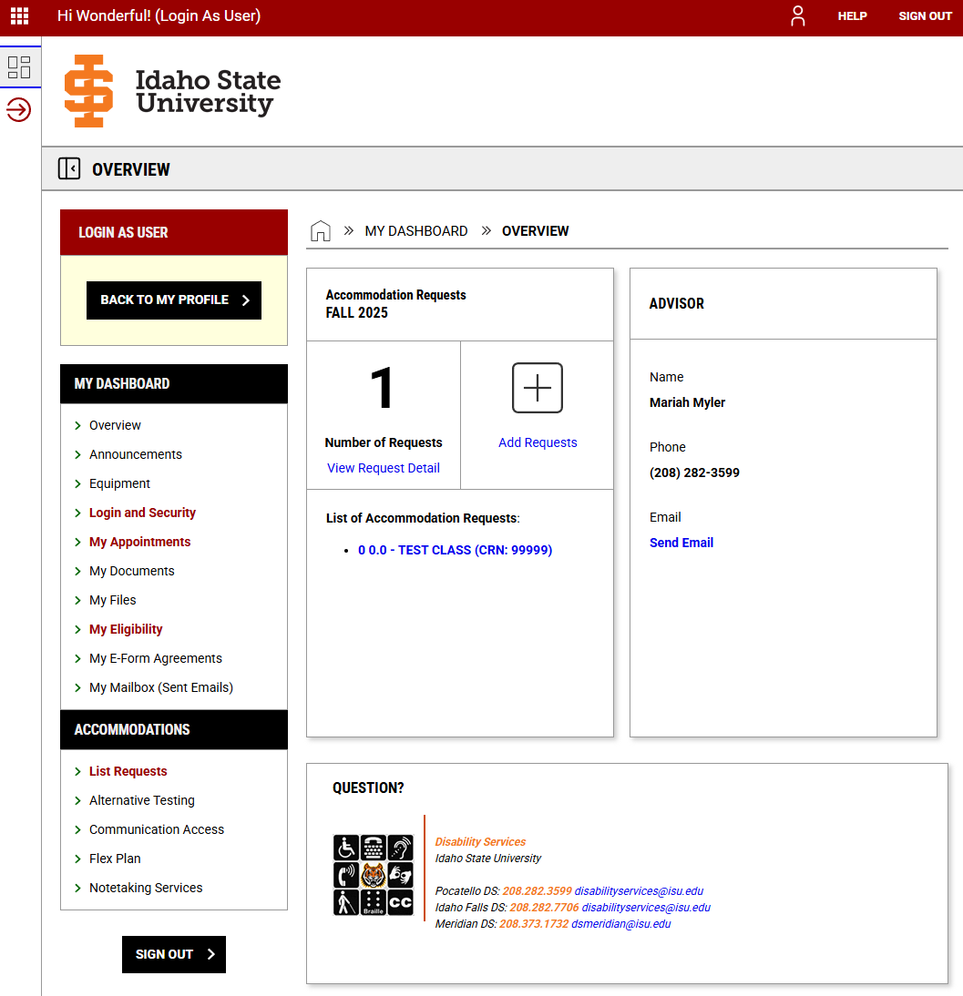

# Requesting your accommodation

After your intake appointment, your specialist will add the accommodations to your profile.



**Your AIM student profile may take up to 24 hours to sync with ISU's Banner system.**

From your Overview dashboard, you can manage your accommodations.

To manage your accommodations, click on "View Request Detail."

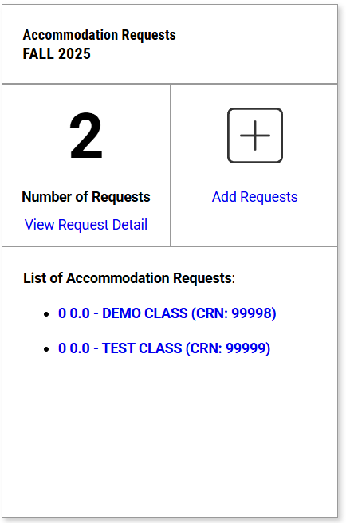

You are then brought to a listing of your accommodations to modify your accommodations. Click 'Modify Request'

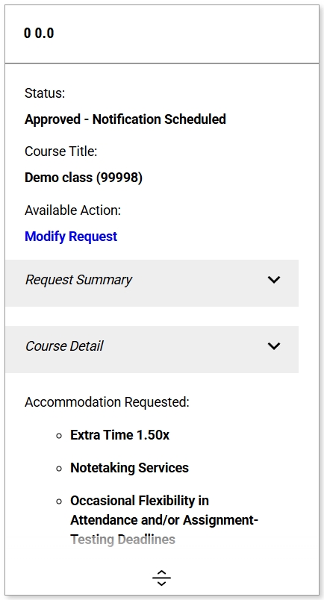

From here, you can apply, remove, or cancel your accommodation. Once a modification request is made, your specialist will be notified and will review your request.

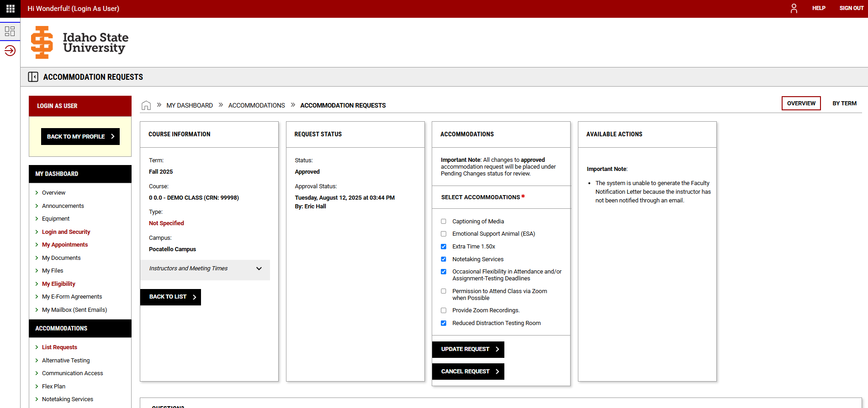

# Scheduling your exams

To schedule your exams, click on 'Alternative Testing' located on the left-hand menu under Accommodations.

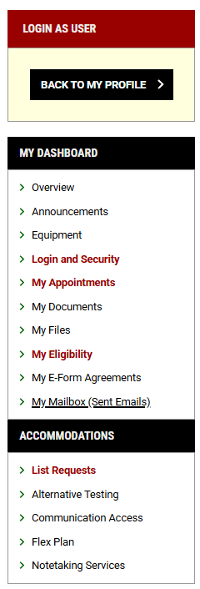

You are then brought to the 'Schedule an Exam' page. From here, select the course you need to schedule your exam.

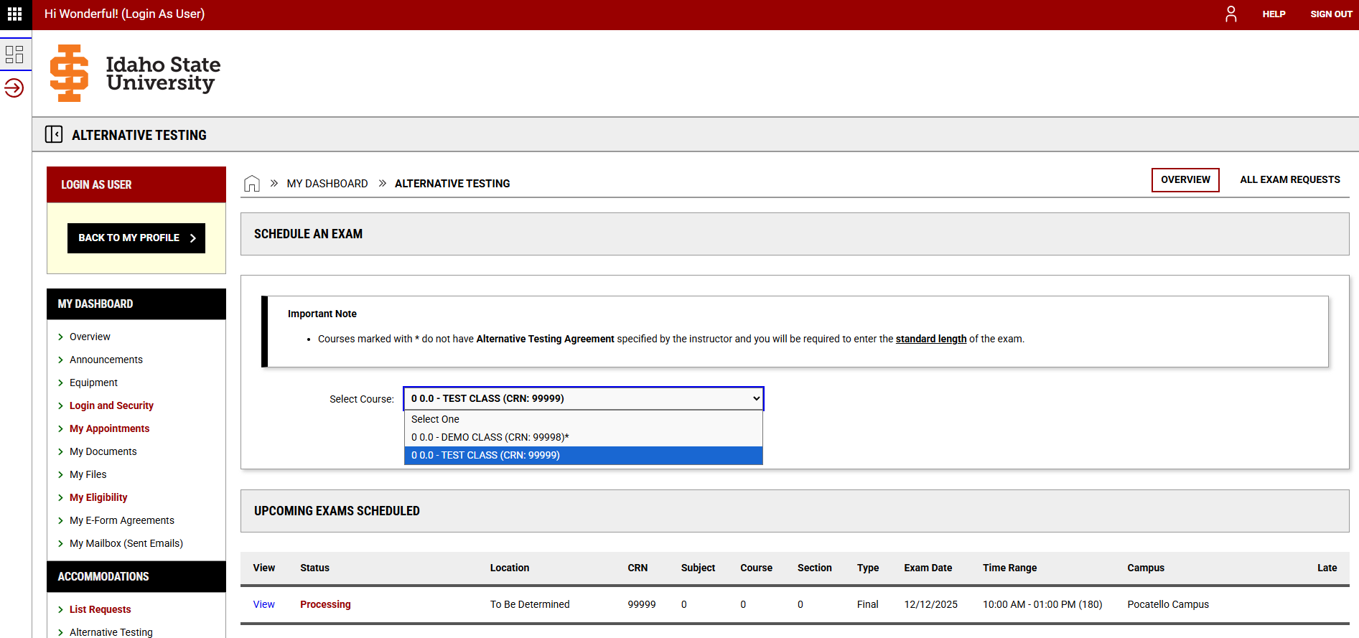

Once selected, click on the "Schedule An Exam" button.

From here you answer complete the request form.

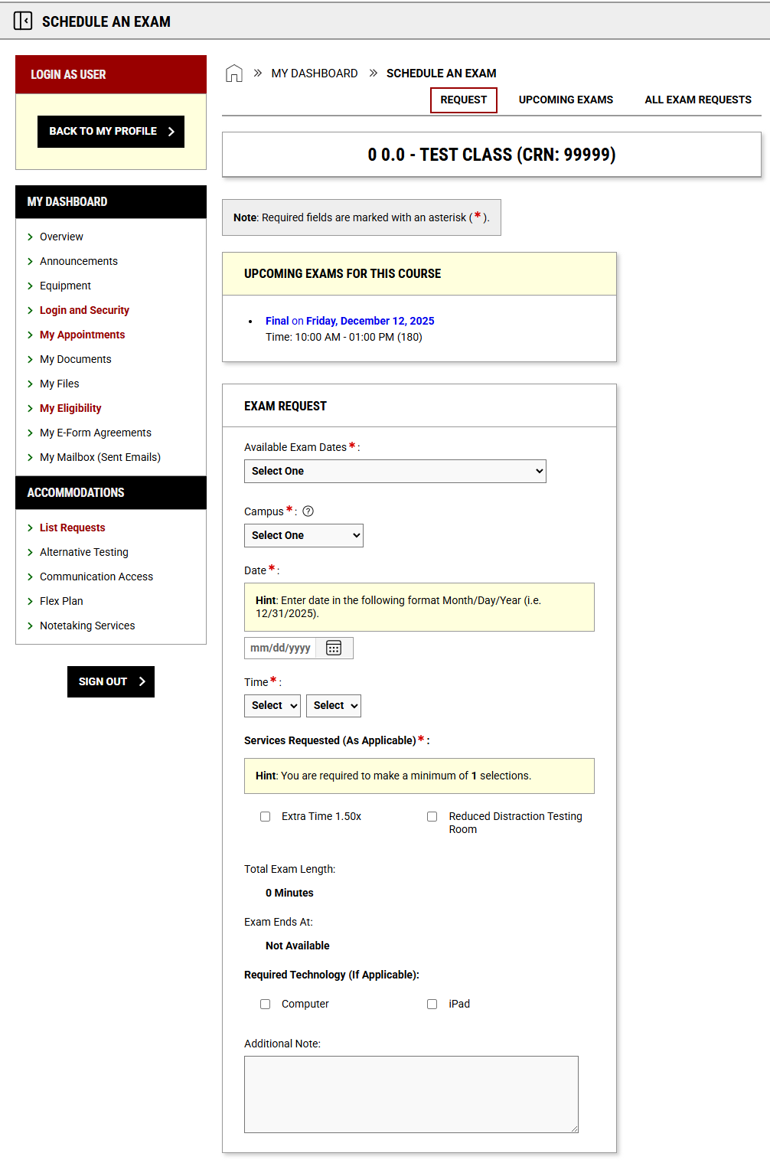



**If your instructor added exam information, the list would prepopulate with the exam information.**

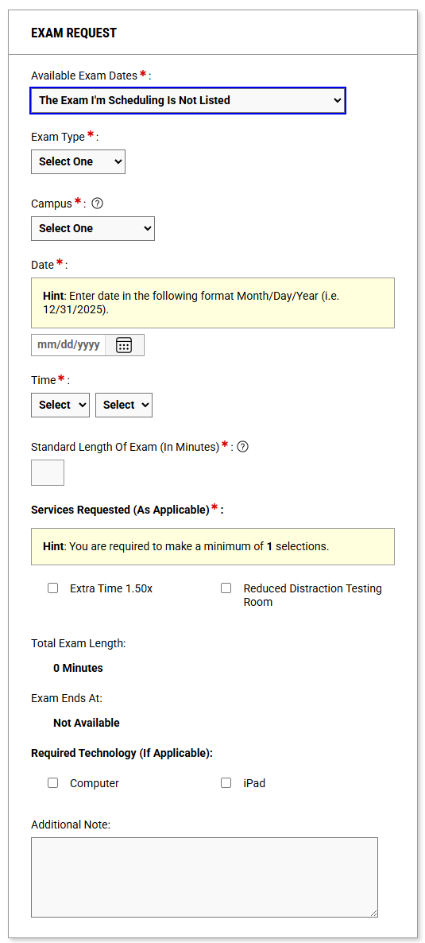

Exam request without predefined testing information

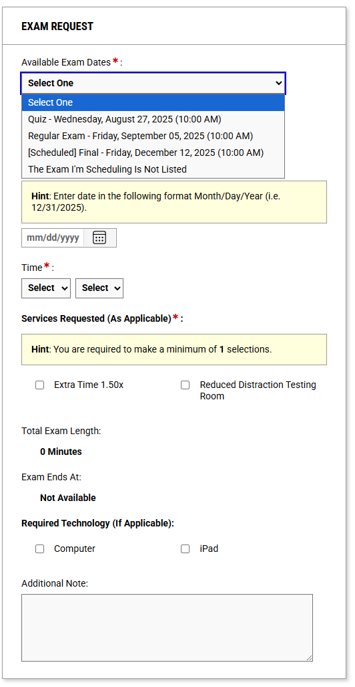  
 Exam request with predefined testing information

If your instructor has not listed their exams, then you have the option to select "The Exam I'm Scheduling is Not Listed" and enter the exam details. If you have any questions or concerns about scheduling your exams, please feel welcome to contact Disability Services at 208-282-3599 or [ada@isu.edu](mailto:ada@isu.edu).

Once the exam request is filled out, click "Add Exam Request". Both the testing center and your instructor will be notified of the request. The testing center will review your request. Your instructor will need to provide Disability Services or an affiliated testing center with the exam, either by uploading the exam through the secure "Upload Exam" link provided in the email notification, by email, or by hand delivery.

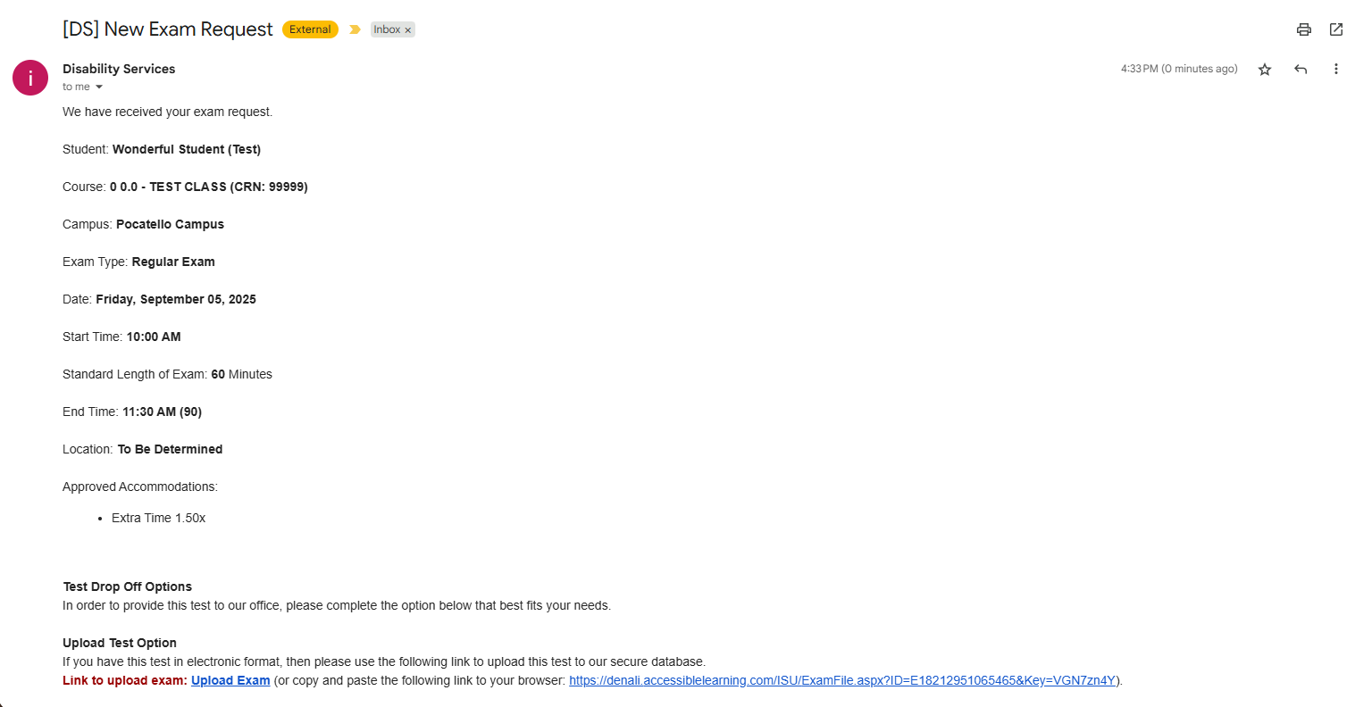

If you have any questions or concerns about scheduling your exams or have questions about the process, please feel welcome to contact Disability Services at 208-282-3599 or [ada@isu.edu](mailto:ada@isu.edu)

# Managing your Flex Plan Accommodation

From your student portal, you can monitor the status of your Flexibility Agreements.

Flex agreements are initiated by the instructor. If the instructor does not initiate the flexibility agreement within three days of being notified, the default Flexibility agreement is put in place.

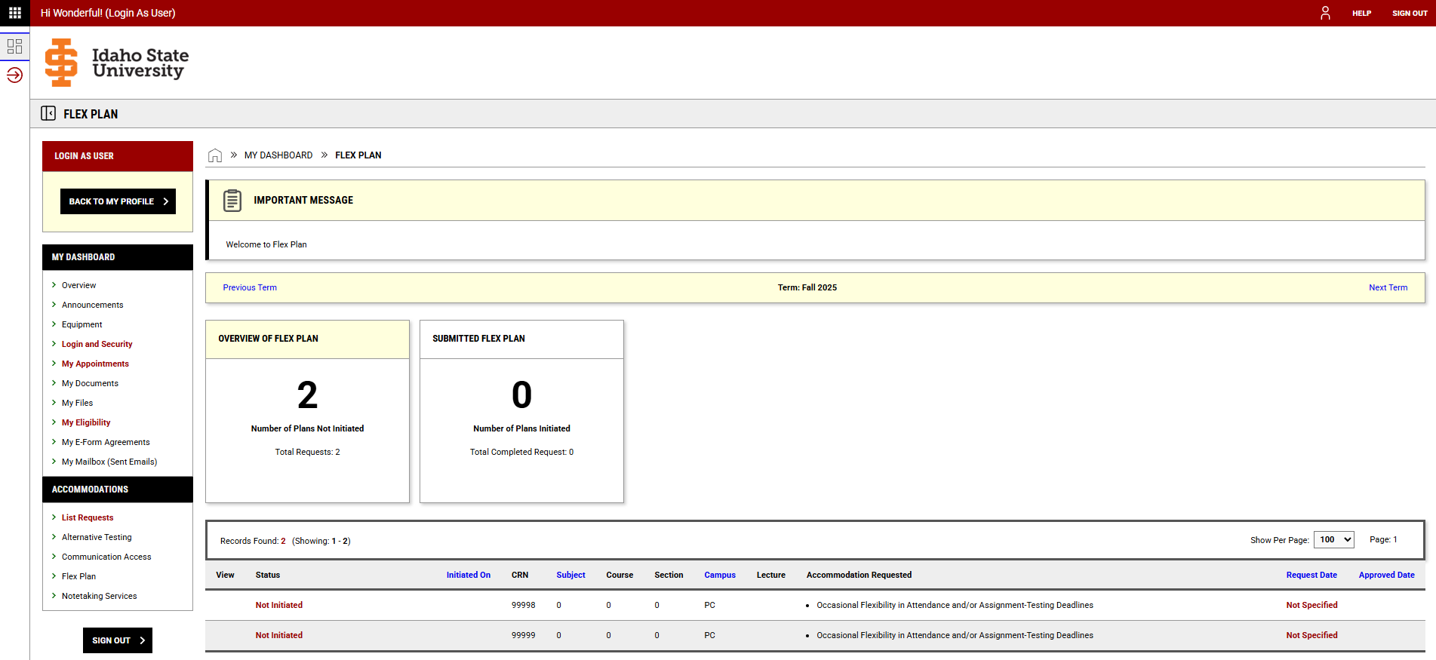

# Notetaking Services

From your student portal, you can view and download notes taken by the assigned note-taker.

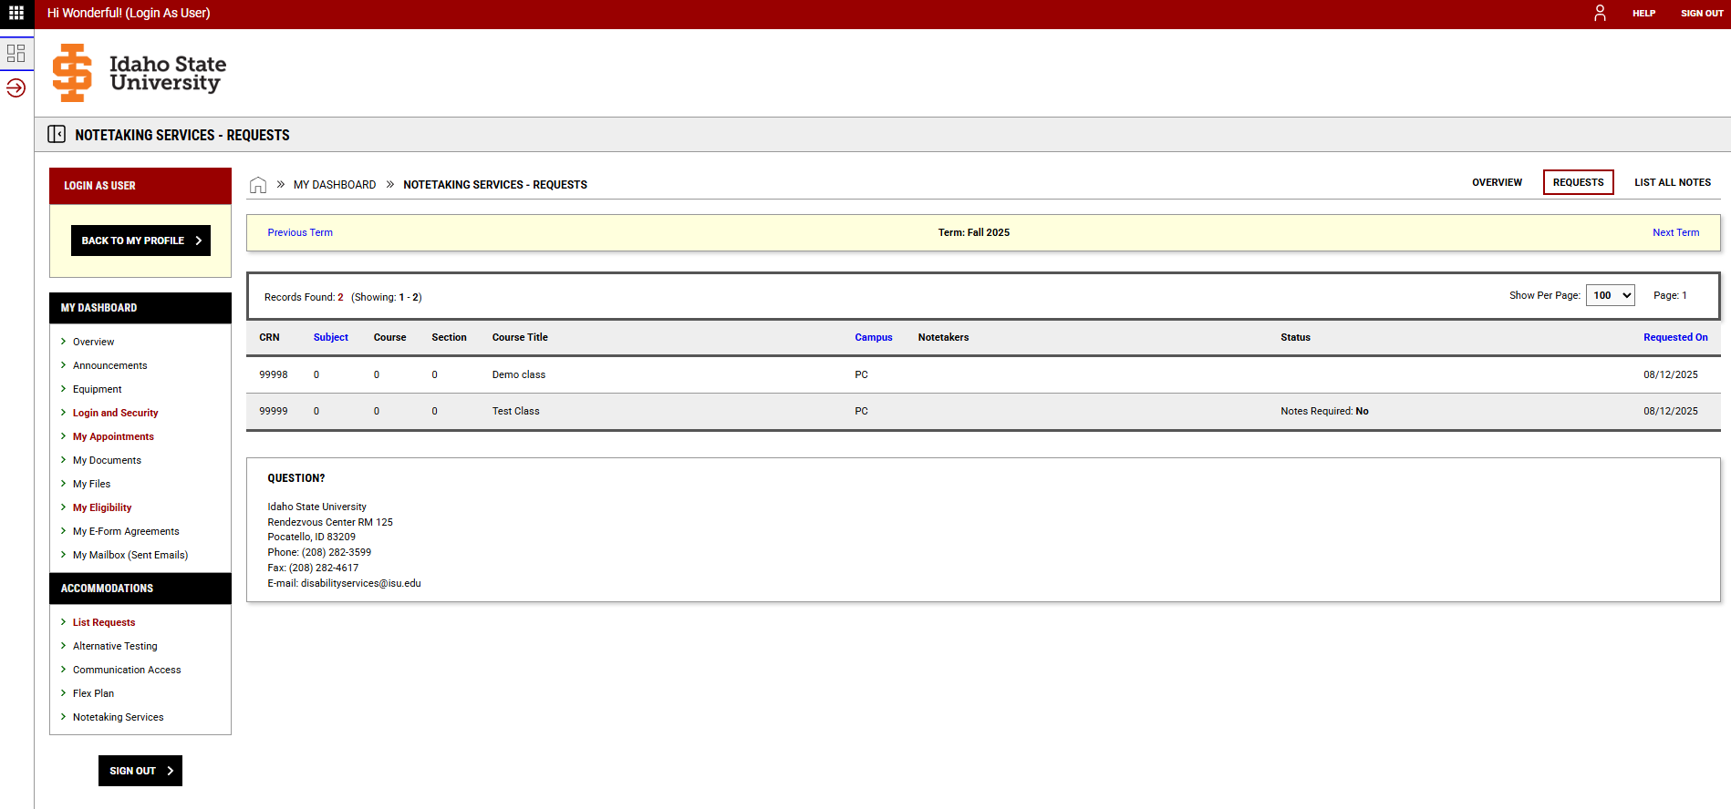

If you have any questions or concerns about your student portal or have questions about the various processes and procedures, please feel free to contact Disability Services at 208-282-3599 or [ada@isu.edu,](mailto:ada@isu.edu) or [schedule](https://calendly.com/halleric-isu/disability-services-appointment?month=2025-08%20) an in-person training with our assistive technologist.