Welcome to your personal Disability Services (DS) instructor portal! Here you will be able to manage your students accommodated testing, flex agreements, and notetaking services.

When you receive a letter with the Alternative testing please read through the entire letter. This letter may contain single or multiple listed accommodation. This letter will provide guidance on how to work with the student and our office to provide such accommodation.

For students with the alternative testing accommodation applied to your class please click on "Alternative Testing Agreement"

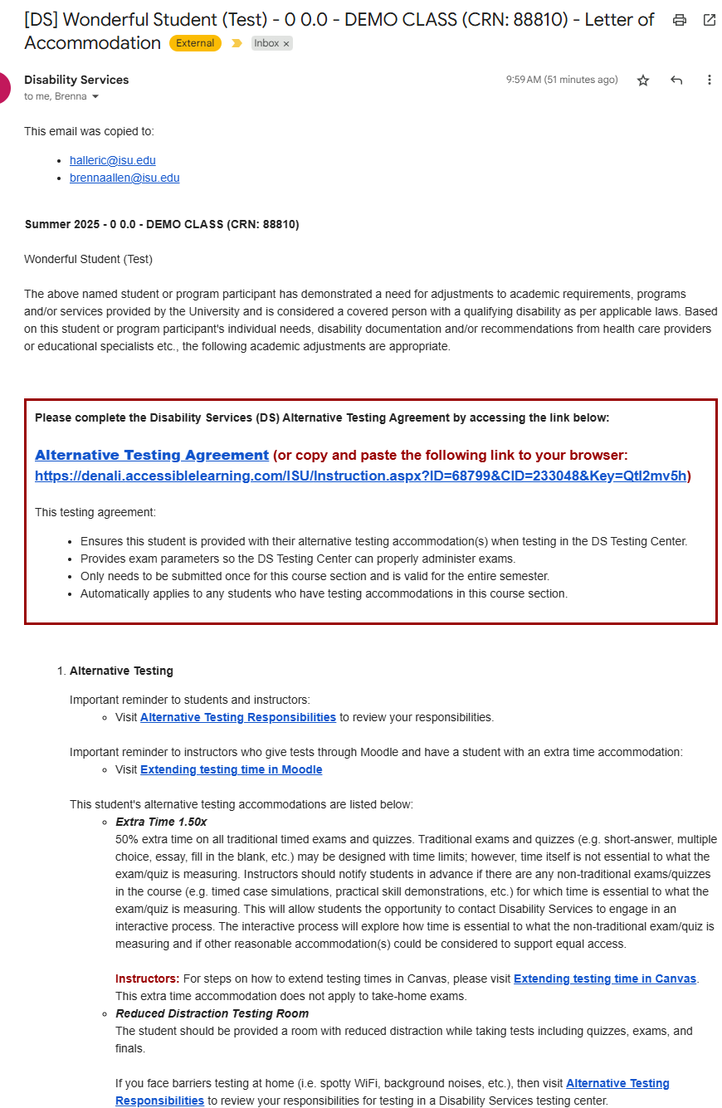

When you click on the "Alternative Testing Agreement link you will be brought to a list of questions which provide a default/baseline set of instructions which are used to administer your exam in Disability Services & DS affiliate testing centers as shown below. Once the form is completed click on "Update and view Exam Dates" you will receive an automated copy of this testing agreement. As shown below.

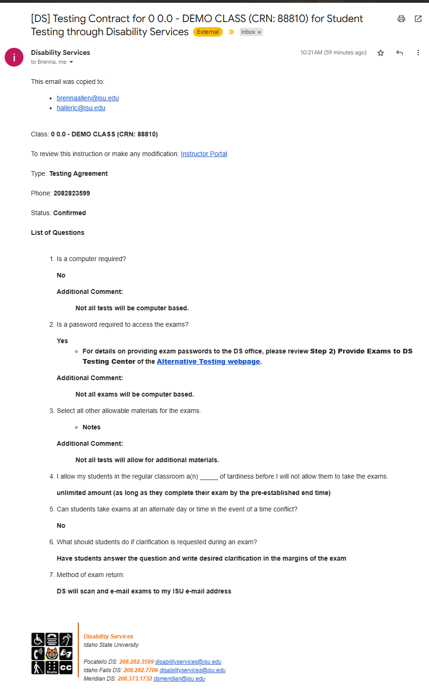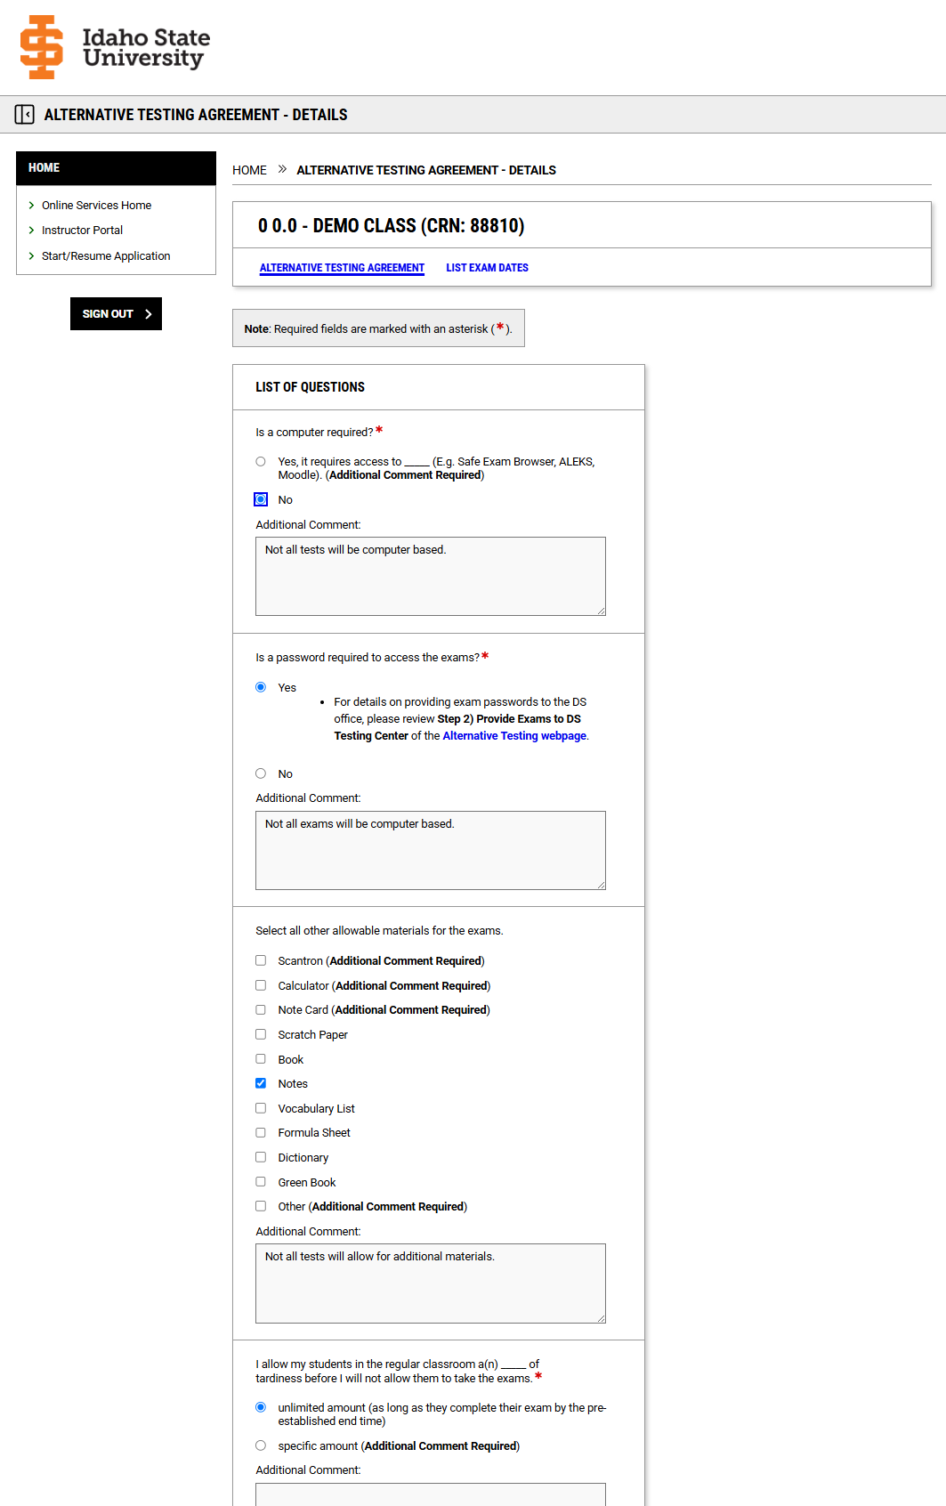

Automated email copy of the Alternative Testing Agreement.

Alternative Testing Agreement Form

After you click on "Update and view Exam Dates" You will be directed to the "List Exam Dates" where you will have the option to build a list of exam details, exam date instructions such as additional testing materials for each quiz, exam, mid-term, & Finals. You also have the opportunity to upload the exam which will be securely sent to the DS testing center.

This list of exams & dates will also populate a list of available exams for your student to choose from in their Disability Services Student portal. An example of what your students will see is shown below.

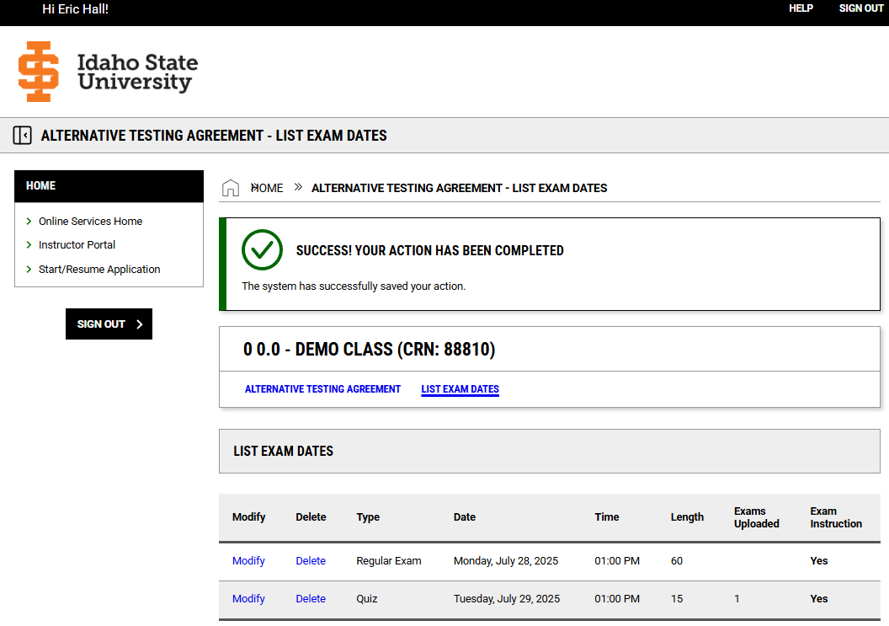

Populated List of Exams and dates.

Option to Upload Exam File located at the end of exam instructions.

Exam details and Exam date instructions

This is what the students will see on their end.

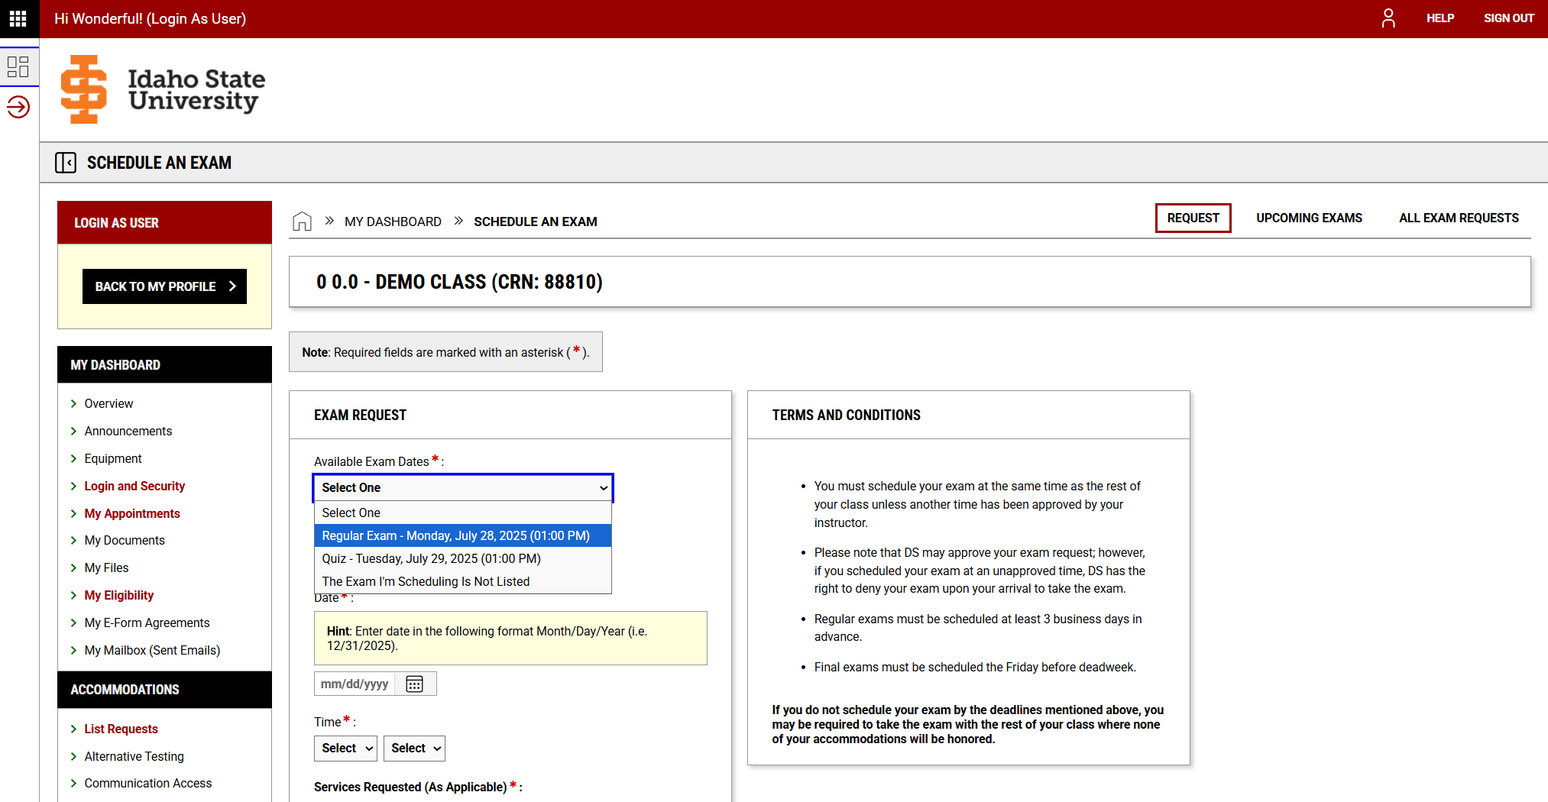

If you don't list the exams the student will have the opportunity to enter and request an exam.

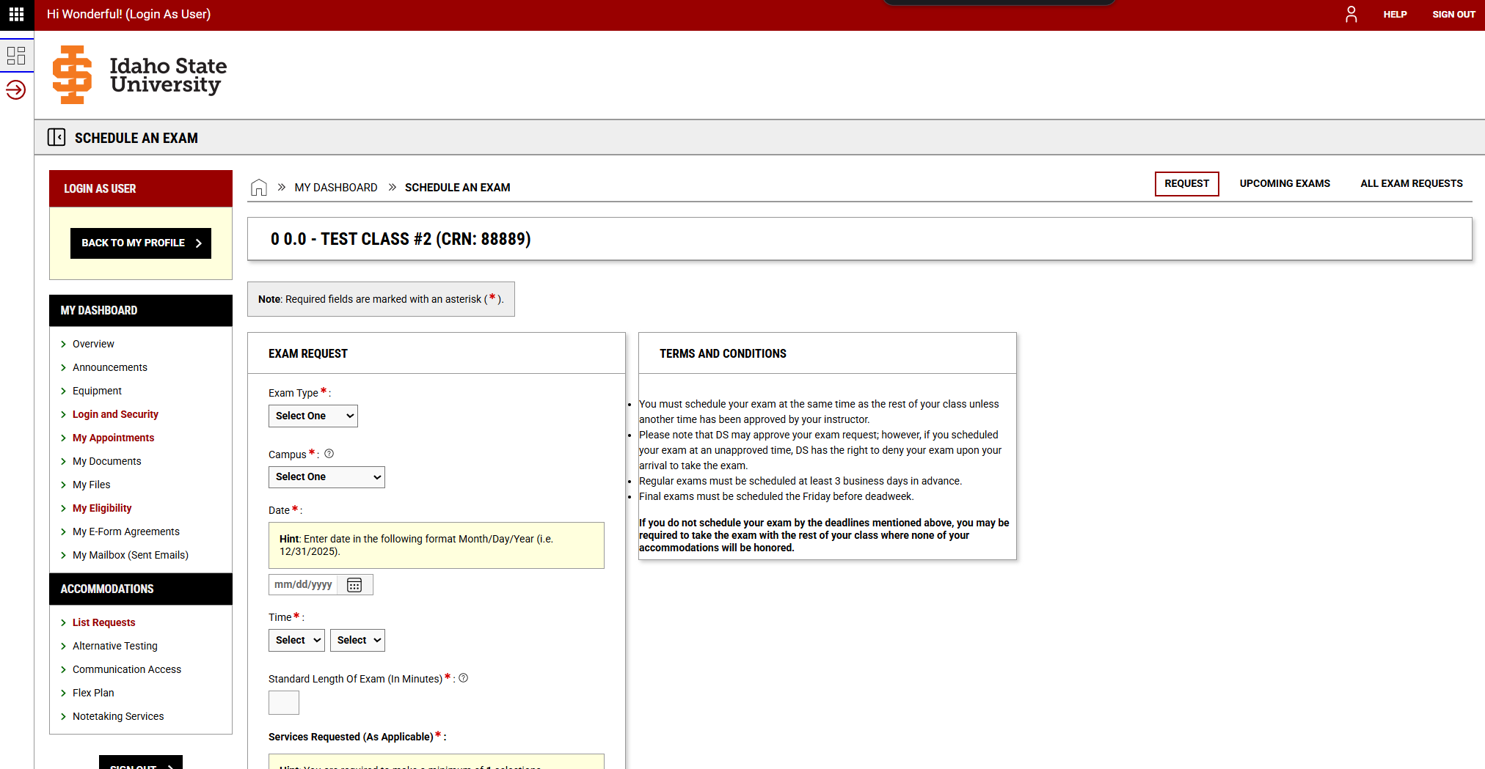

Once a request is made you will receive an automated email notifying you the student has scheduled to take their exam in a disability services testing center. 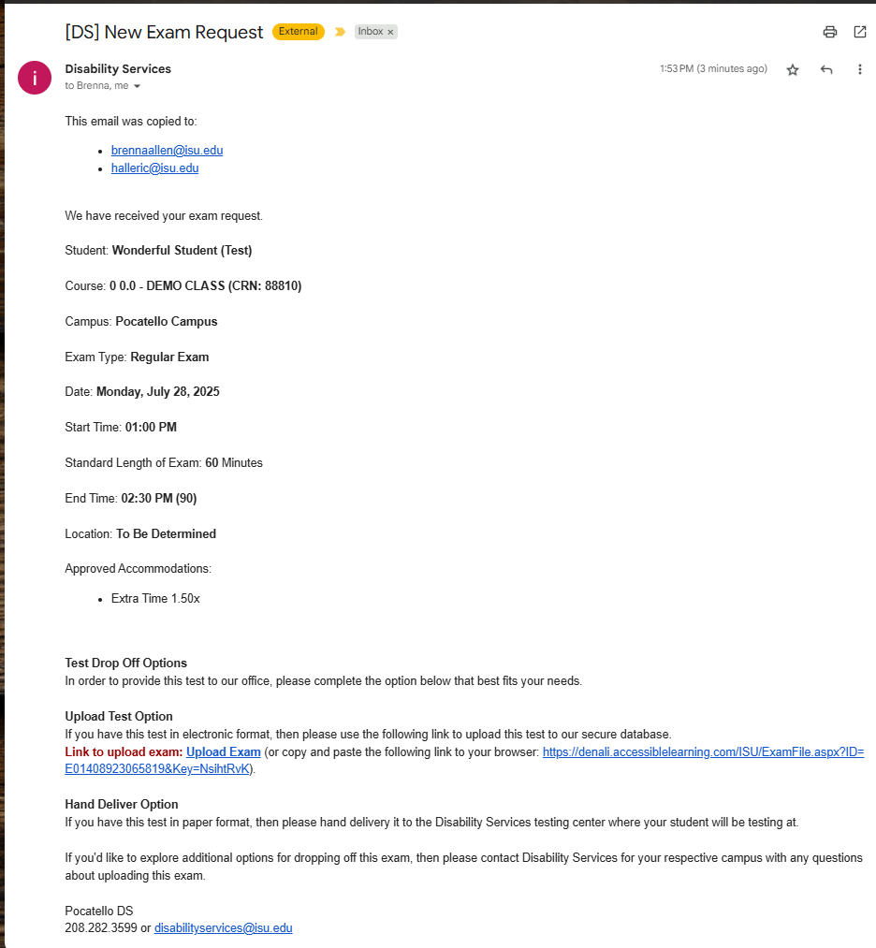

This automated message provided a secure link to upload the exam to the testing center, if you have not yet done so. Clicking on the Upload link You are greeted with the opportunity to upload the exam for exam file to all students scheduled with the same exam date. or upload the exam file available only to this individual student's exam.

The exam may also be physically delivered to a Disability Services office:

# Disability Services Office Locations

**Pocatello**  
Rendezvous Complex, Room 125  
921 S 8th Ave, Stop 8121  
Pocatello, Idaho 83209-8121  
Phone: [208-282-3599](tel:208-282-3599)  
Fax: 208-282-4617  
Email: [ada@isu.edu](mailto:ada@isu.edu)

**Idaho Falls**  
BSUB Building, Room 202  
1784 Science Center Dr.  
Idaho Falls, Idaho 83402  
Phone: 208-282-7706  
Email: [ifexams@isu.edu](mailto:ifexams@isu.edu)

**Meridian**  
Sam and Aline Skaggs Health Science Center, Room 841  
1311 E Central Drive  
Meridian, Idaho 83642  
Phone: 208-373-1960  
Fax: 208-373-1826  
Email: [meridiantesting@isu.edu](mailto:meridiantesting@isu.edu)

Let's begin by clicking Alternative Testing located on the left-hand side of your screen. If you are unable to locate Alternative Testing on the left side of your screen, click on the horizontal lines found under the ISU logo.

In the Alternative testing module, you will be able to:

1. Complete your testing agreement
2. List your exams to make the dates and times available for students to select from.
3. Track upcoming exam your student has scheduled with our testing services
4. Securely download completed exams

# Complete your testing agreement

When you click on your alternative testing agreement you will be brought to a list of classes needing your agreement completed. Click on the **"View/Modify Alternative Testing agreement."**

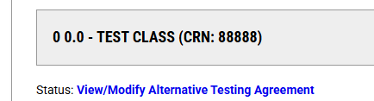

You will then be brought to a List of Questions which need to be completed.

Once the questions have been completed click on **"Update & view exam dates"**

# List your exams to make the dates and times available for students to select from.

This next step is to list all of your Quizzes, Exams, Midterms, & Final for the semester.

If no exams are listed and made available to the student. The student will be able to select The Exam I'm Scheduling is Not Listed.and then schedule their exam and manually add dates and time. Once a test or quiz is scheduled by the student you will receive a notification to provide our Disability Services testing staff with the test or quiz in question.

If you **List Exam Dates** and times, they will populate in your student's portal and they will be able to select from the list you generate.

**Instructor portal / alternative testing / List Exam Dates**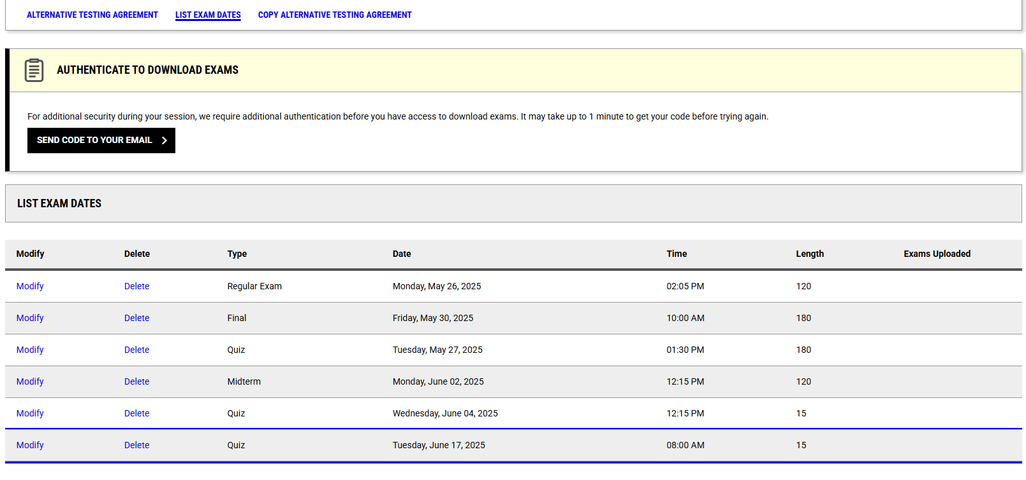

**Student portal / alternative testing / Schedule Exam**

