POCATE

**Department of Counseling**

**Clinical Rehabilitation Counseling**

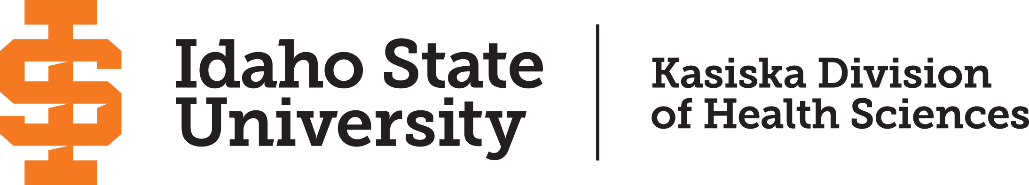

**CLINICAL REHABILITATION COUNSELING**

**LEADING TO THE DEGREE**

**MASTER OF COUNSELING (M.COUN.)**

The master’s specialty practice area in Clinical Rehabilitation Counseling is designed to prepare counselors to provide individual and group counseling in a variety of settings such as vocational rehabilitation (Idaho Division of Vocational Rehabilitation, Commission for the Blind and Visually Impaired), certified rehabilitation providers like Community Partnership Of Idaho, various mental health agencies, the Veterans Administration, disability student services with various academic institutions, integrated behavioral health, nonprofits, and private practice.

A. **General Residency Requirement.** For the Master of Counseling (M.COUN.) specialty practice area, the student is required to complete the equivalent of at least four full semesters of resident graduate study beyond the bachelor's degree. The minimum Clinical Rehabilitation Counseling program must total 60 semester hours.

B. **Specific Counseling Specialty Practice Area Requirements**

|  |  |  |
| --- | --- | --- |
| COUN 6615 | Foundations of Clinical Rehabilitation Counseling | 3 credits |
| COUN 6616 | Professional Issues in Clinical Rehabilitation Counseling | 3 credits |
| COUN 6617 | Medical Aspects of Disability | 2 credits |
| COUN 6697 | Practicum in Counseling | 2 credits |
| COUN 6697L | Practicum in Counseling Lab | 0 credits |
| COUN 6698 | Internship in Counseling | 18 credits* |
| COUN 6698L | Internship in Counseling Lab | 0 credits |

C. **General Degree Requirements**

|  |  |  |
| --- | --- | --- |
| COUN 6611 | Applied Statistics and Research | 2 credits |
| COUN 6612 | Assessment and Diagnosis in Counseling | 3 credits |
| COUN 6614 | Life Span Development | 2 credits |
| COUN 6621 | Professional Orientation and Ethics | 2 credits |
| COUN 6623 | Lifestyle and Career Development | 2 credits |
| COUN 6624 | Cultural Counseling | 3 credits |
| COUN 6625 | Crisis Intervention and Trauma | 3 credits |
| COUN 6627 | Conceptualizing Counseling Theory | 3 credits |
| COUN 6630 | Addictions Counseling | 3 credits |
| COUN 6660 | Theories of Family and Couple Counseling | 3 credits |
| COUN 6677 | Group Counseling Techniques | 3 credits |
| COUN 6696 | Prepracticum Counseling Techniques | 3 credits |
|  | **Total Credits** | **60 credits** |
|  |  |  |

*\*Must total 18 credits across all semesters*

**Curriculum Effective August 2024. Rev. 05/2025**

**Course Sequence**

|  |  |  |
| --- | --- | --- |
| FIRST YEAR | | |
| Fall Semester | | |
| COUN 6621 | Professional Orientation and Ethics | 2 credits |
| COUN 6624 | Cultural Counseling | 3 credits |
| COUN 6627 | Conceptualizing Counseling Theory | 2 credits |
| COUN 6615 | Foundations of Clinical Rehabilitation Counseling | 3 credits |
| COUN 6696 | Prepracticum Counseling Techniques | 3 credits |
| Spring Semester | | |
| COUN 6623 | Lifestyle and Career Development | 2 credits |
| COUN 6625 | Crisis Intervention and Trauma | 2 credits |
| COUN 6616 | Professional Issues in Clinical Rehabilitation Counseling | 3 credits |
| COUN 6660 | Theories of Family and Couple Counseling | 3 credits |
| COUN 6697 | Practicum in Counseling | 2 credits |
| COUN 6697L | Practicum in Counseling Lab | 0 credits |
| Summer Session | | |
| COUN 6617 | Medical Aspects of Disability | 2 credits |
| COUN 6698 | Internship in Counseling | 2 credits |
| COUN 6698L | Internship in Counseling Lab | 0 credits |
| SECOND YEAR | | |
| Fall Semester | | |
| COUN 6612 | Assessment and Diagnosis in Counseling | 3 credits |
| COUN 6614 | Life Span Development | 2 credits |
| COUN 6677 | Group Counseling Techniques | 3 credits |
| COUN 6698 | Internship in Counseling | 1-9 credits |
| COUN 6698L | Internship in Counseling Lab | 0 credits |
| Spring Semester | | |
| COUN 6611 | Applied Statistics and Research | 2 credits |
| COUN 6630 | Addictions Counseling | 3 credits |
| COUN 6698 | Internship in Counseling | 1-9 credits |
| COUN 6697L | Practicum in Counseling Lab | 0 credits |
|  | **Total Credits** | **60 credits** |

*\*Specialty does not need an elective*

**Curriculum Effective August 2024. Rev. 05/2025**