**Affiliate Faculty Instructions and Workflow**

Rev. April 2025

Please contact Michelle Collier in Academic Affairs with any questions regarding the form or the process ([michellecollier@isu.edu](mailto:michellecollier@isu.edu) or x6311)

Workflow:

Step 1: Initiator (this can be anyone – Admin Assistant, Dept Chair, etc.) will fill in **all** the following fields:

* Title and Name of Affiliate Nominee
* Address
* City, State, Zip Code
* Phone Number
* Birth Date
* Email
* Emergency Contact and Number
* Attach CV
* ISU College and Department Name
* Department Contact (typically the Department Chair)
* Academic Year (use the current academic year)
* Length of Requested Appointment
* Duties to be performed by nominee
* Initiator will initial at the bottom of page 1

Step 2: Department Chair

* Will review the document if completed by someone else
* Add name, signature and date on page 2

Step 3: Dean

* Review document
* Add name, signature and date on page 2

Step 4: Affiliate Faculty Nominee

* Will read pages 3 and 4
* Sign and date on page 4

Step 5: Academic Affairs Project Coordinator will fill in the following fields:

* Bengal ID
* Banner ID
* Select New or Renewal
* Initial on page 2

Step 6: Provost will fill in the following fields:

* Select Approved or Denied
* Comments – optional to add
* Add name, signature and date on page 2

Below is the form showing the fields to be filled in. All fields are required (except for the “comments” field for the Provost)

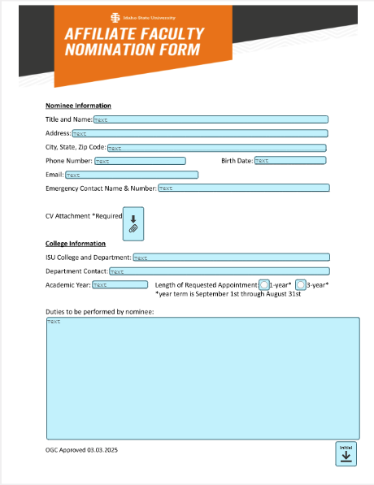

Initiator

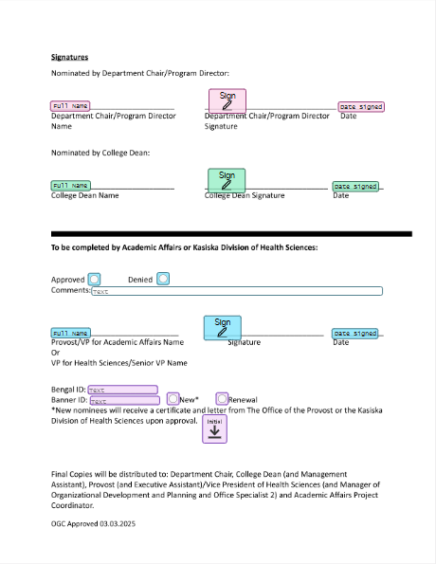

Department Chair

Dean

Provost

Academic Affairs Project Coordinator

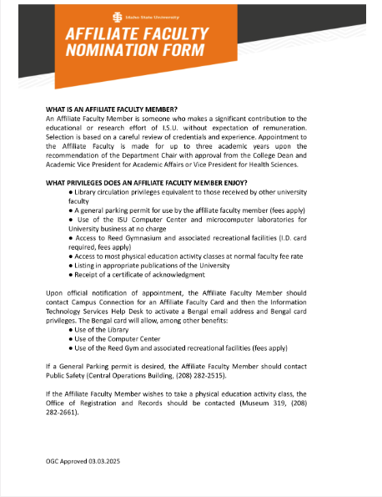

Affiliate Faculty Nominee – Read

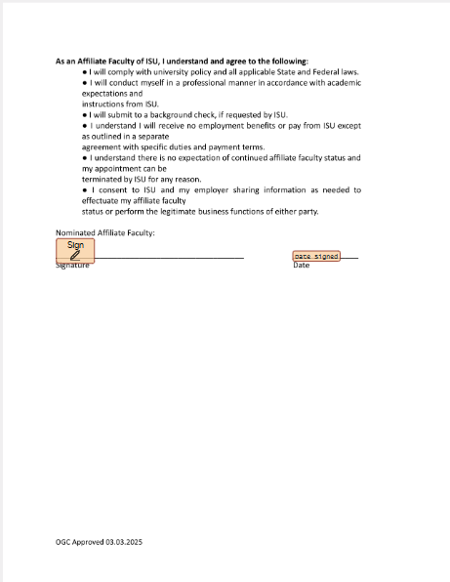

Affiliate Faculty Nominee